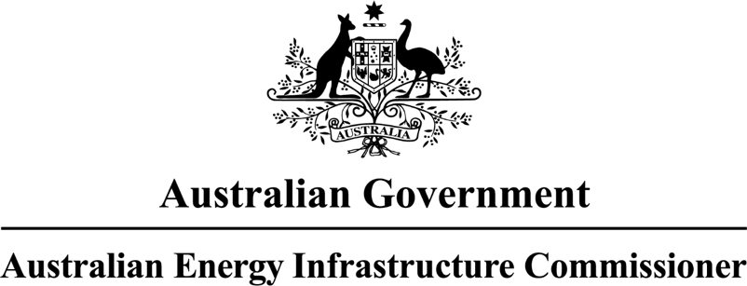

# **Annual Report**

to the Parliament of Australia

**Year ending 31 December 2024**

ISBN: 978-1-7635223-2-9 [Print]

ISBN: 978-1-7635223-3-6 [Digital]

© Commonwealth of Australia 2025

**Ownership of intellectual property rights**

Unless otherwise noted, copyright (and any other intellectual property rights) in this publication is owned by the Commonwealth of Australia (referred to as the Commonwealth).

**Creative Commons licence**

All material in this publication is licensed under a [Creative Commons Attribution 4.0 International Licence](https://creativecommons.org/licenses/by/4.0/legalcode) except content supplied by third parties, logos and the Commonwealth Coat of Arms.

Inquiries about the licence and any use of this document should be submitted via our online contact [form](https://www.dcceew.gov.au/about/contact).



**Cataloguing data**

This publication (and any material sourced from it) should be attributed as: 2*024 Annual Report of the Australian Energy Infrastructure Commissioner*, Commonwealth of Australia 2025. CC BY 4.0.

This publication is available at [www.aeic.gov.au](http://www.aeic.gov.au)

**Disclaimer**

The Australian Government acting through the Department of Climate Change, Energy, the Environment and Water has exercised due care and skill in preparing and compiling the information and data in this publication. Notwithstanding, the Department of Climate Change, Energy, the Environment and Water, its employees and advisers disclaim all liability, including liability for negligence and for any loss, damage, injury, expense or cost incurred by any person as a result of accessing, using or relying on any of the information or data in this publication to the maximum extent permitted by law.

The views and opinions expressed in this publication are those of the authors and do not necessarily reflect those of the Australian Government, relevant Portfolio Ministers, or the Department of Climate Change, Energy, the Environment and Water.

**Acknowledgement of Country**

We acknowledge the Traditional Owners of Country throughout Australia and recognise their continuing connection to land, waters and culture. We pay our respects to their Elders past and present.

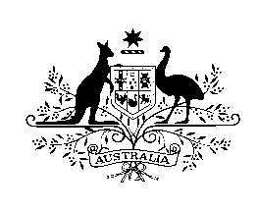

**Australian Energy Infrastructure Commissioner**

28 March 2025

The Hon Chris Bowen, MP

Minister for Climate Change and Energy

Parliament House

CANBERRA ACT 2600

Dear Minister

**Re: 2024 Annual Report of the Office of the Australian Energy Infrastructure Commissioner**

Pursuant to my Terms of Reference, I am pleased to provide the 2024 Annual Report to the Australian Parliament on the activities of the Office of the Australian Energy Infrastructure Commissioner.

This report covers the Office’s activities for the period of 1 January 2024 through to 31 December 2024.

Sincerely

  
Anthony (Tony) Mahar

**Australian Energy Infrastructure Commissioner**

PO Box 24434, Melbourne VIC 3001  
1800 656 395   
[www.aeic.gov.au](http://www.aeic.gov.au)

Contents

COMMISSIONER’S INTRODUCTION 3

The year in-review 3

The year ahead 4

OFFICE OVERVIEW 6

Brief history of the AEIC 6

Time of transition 6

Operational arrangements 6

Other resourcing changes 7

Contact details 7

CASE DATA 8

Helping communities get useful information and practical outcomes 8

Total case activity in 2024 8

Continuation of key trends 10

Themes and emerging insights 10

STAKEHOLDER ENGAGEMENT 15

Building bridges and making connections 15

Meeting people where they are 15

Project and systems-level engagement 17

Other public platforms 17

TRANSPARENCY AND BEST PRACTICE 19

Community Engagement Review (2023) 19

*The AEIC’s role to-date and 2024 activities* 19

*Next steps in 2025* 20

Other practical advice, formal input, and collaborative initiatives 20

APPENDIX A: Terms of Reference 21

APPENDIX B: Excerpts from the *Community Engagement Review* (2023) 22

Contact details 24

# COMMISSIONER’S INTRODUCTION

I am pleased to deliver the ninth Annual Report to the Australian Parliament on the work of the Office of the Australian Energy Infrastructure Commissioner.

This 2024 report covers the period 1 January 2024 to 31 December 2024.

I started in the role of Commissioner on 19 December 2024, at the end of the reporting year, taking over from John Sheldon who had been acting as the interim Commissioner from April to December 2024. John was appointed following the retirement of Andrew Dyer, the inaugural Commissioner, who finished in the role on 31 March 2024 after nearly nine years.

I’d like to thank both John and Andrew for their work in their respective roles over the reporting period.

## The year in-review

The 2024 year was important both for responding to the complaints and concerns across the nation in relation to energy infrastructure, and particularly in relation to setting the pathway forward on actions and initiatives that will be progressed to achieve positive outcomes for the community in relation to the energy transition.

The Australian Government’s Community Engagement Review (the Review) was led by the previous Commissioner, Andrew Dyer, and completed in late 2023. The Review made nine recommendations across six themes on ways to address identified concerns and foster community support and participation in Australia’s renewable energy transition. In February 2024 the Australian Government released the report with in full or in principle support to all recommendations, and committed to working in collaboration with state and territory governments on implementation through the [Energy and Climate Change Ministerial Council (ECMC)](https://www.energy.gov.au/energy-and-climate-change-ministerial-council). In July 2024 the ECMC released a full response to the Review, including a schedule of more than 170 in progress and new actions and activities aligned to delivery of the recommendations.

The role of the AEIC was strengthened in response to concerns and challenges that were raised in the Review, and the capacity of the Office team increased. Through recruitment processes in the second half of the year, all positions were filled and I am pleased to say we now have an improved ability to ensure the findings of the review will not be left unattended. For much of 2024 there was some lower capacity within the Office with departure of some longer-term staff, vacancies and use of contract staff to support delivery whilst recruitment was completed, along with an interim Commissioner. Despite some of the challenges this brought to delivery, much was still achieved.

In 2024 we recorded our 1000th distinct case since the Commissioner’s role was first created in 2015. We recorded 152 new cases, and closed 155 cases, making it our third busiest year on record.   
This shows the continued need for and value of the role we play in helping community with specific proposals, whilst continuing to work on more broadscale improvements.

More than 330 stakeholder meetings were attended, across a broad range of government, industry, First Nations and community sectors.

Field visits to meet people at the location of proposals continued to be an important pathway to understanding concerns.

## The year ahead

My initial observations have confirmed that as Australia inevitably transitions from ageing coal-fired power stations to a cleaner, more reliable and affordable energy future, the conversation surrounding new energy infrastructure continues to intensify. While there are some constructive and positive outcomes being achieved, there are significant concerns being raised in communities and lessons to be learned and ongoing community challenges that must be addressed. This needs to be a collective agenda that the AEIC can help drive and lead where appropriate.

It is my intention to actively pursue and seek collaboration to progress the recommendations from the Community Engagement Review so that Australia’s energy transition is undertaken in a better way, that it gets the shared benefits right and energy infrastructure projects are done well and can be at the heart of vibrant economies.

As we progress through 2025 it is vital that stakeholders come together and work openly and constructively. It is clear from my discussions across the country and across the industry that there are major concerns in some regions that need to be addressed. Having said that my observations are there is a willingness to ensure we get a better balance between core pillars of equity, transparency, and meaningful engagement – matched with a more certain and timely investment atmosphere.

We look forward to continuing to document and prosecute improvements and adoption of best practices, playing an essential role helping to increase community understanding and acceptance of energy transition projects, particularly through an ongoing accountability on both industry and government with engagement methods and partnerships

The challenges and opportunities we face as we collectively address the energy transition are not new. We have lessons, expertise and technology to assist us and build on. In addition to the Community Engagement Review we have Guidelines, Charters and Commitments that have been developed to act as signposts on the journey. We must see the completion of the Develop Rating Scheme and any other complementary measures that may be required to deliver certainty, transparency and trust amongst stakeholders.

We need to continue to articulate and talk about the reasons for the energy transition, the need for longer term thinking around planning regimes, and a more collegiate approach between government, industry and the community. I am focussed on leading and coordinating a national approach to ensure we can take advantage of the opportunities that are in front of us. Building on the work to date, identifying much need synergies to deliver positive outcomes.

We should focus on shared objectives of affordability, reliability and sustainability to ensure we can efficiently continue the energy transition. Technologies will continue to develop and we are smart enough as a community to learn from the past to enable a better future. We should embrace measures that focus on those key objectives and work collaboratively to streamline and strengthen our approach.

My sincere thanks to the many stakeholders that myself and my team have been able to meet with since commencing in the role late in 2024. These conversations have given life to the real nature of the concerns and experiences and confirmed the importance of our ongoing work.



Tony Mahar  
Australian Energy Infrastructure Commissioner

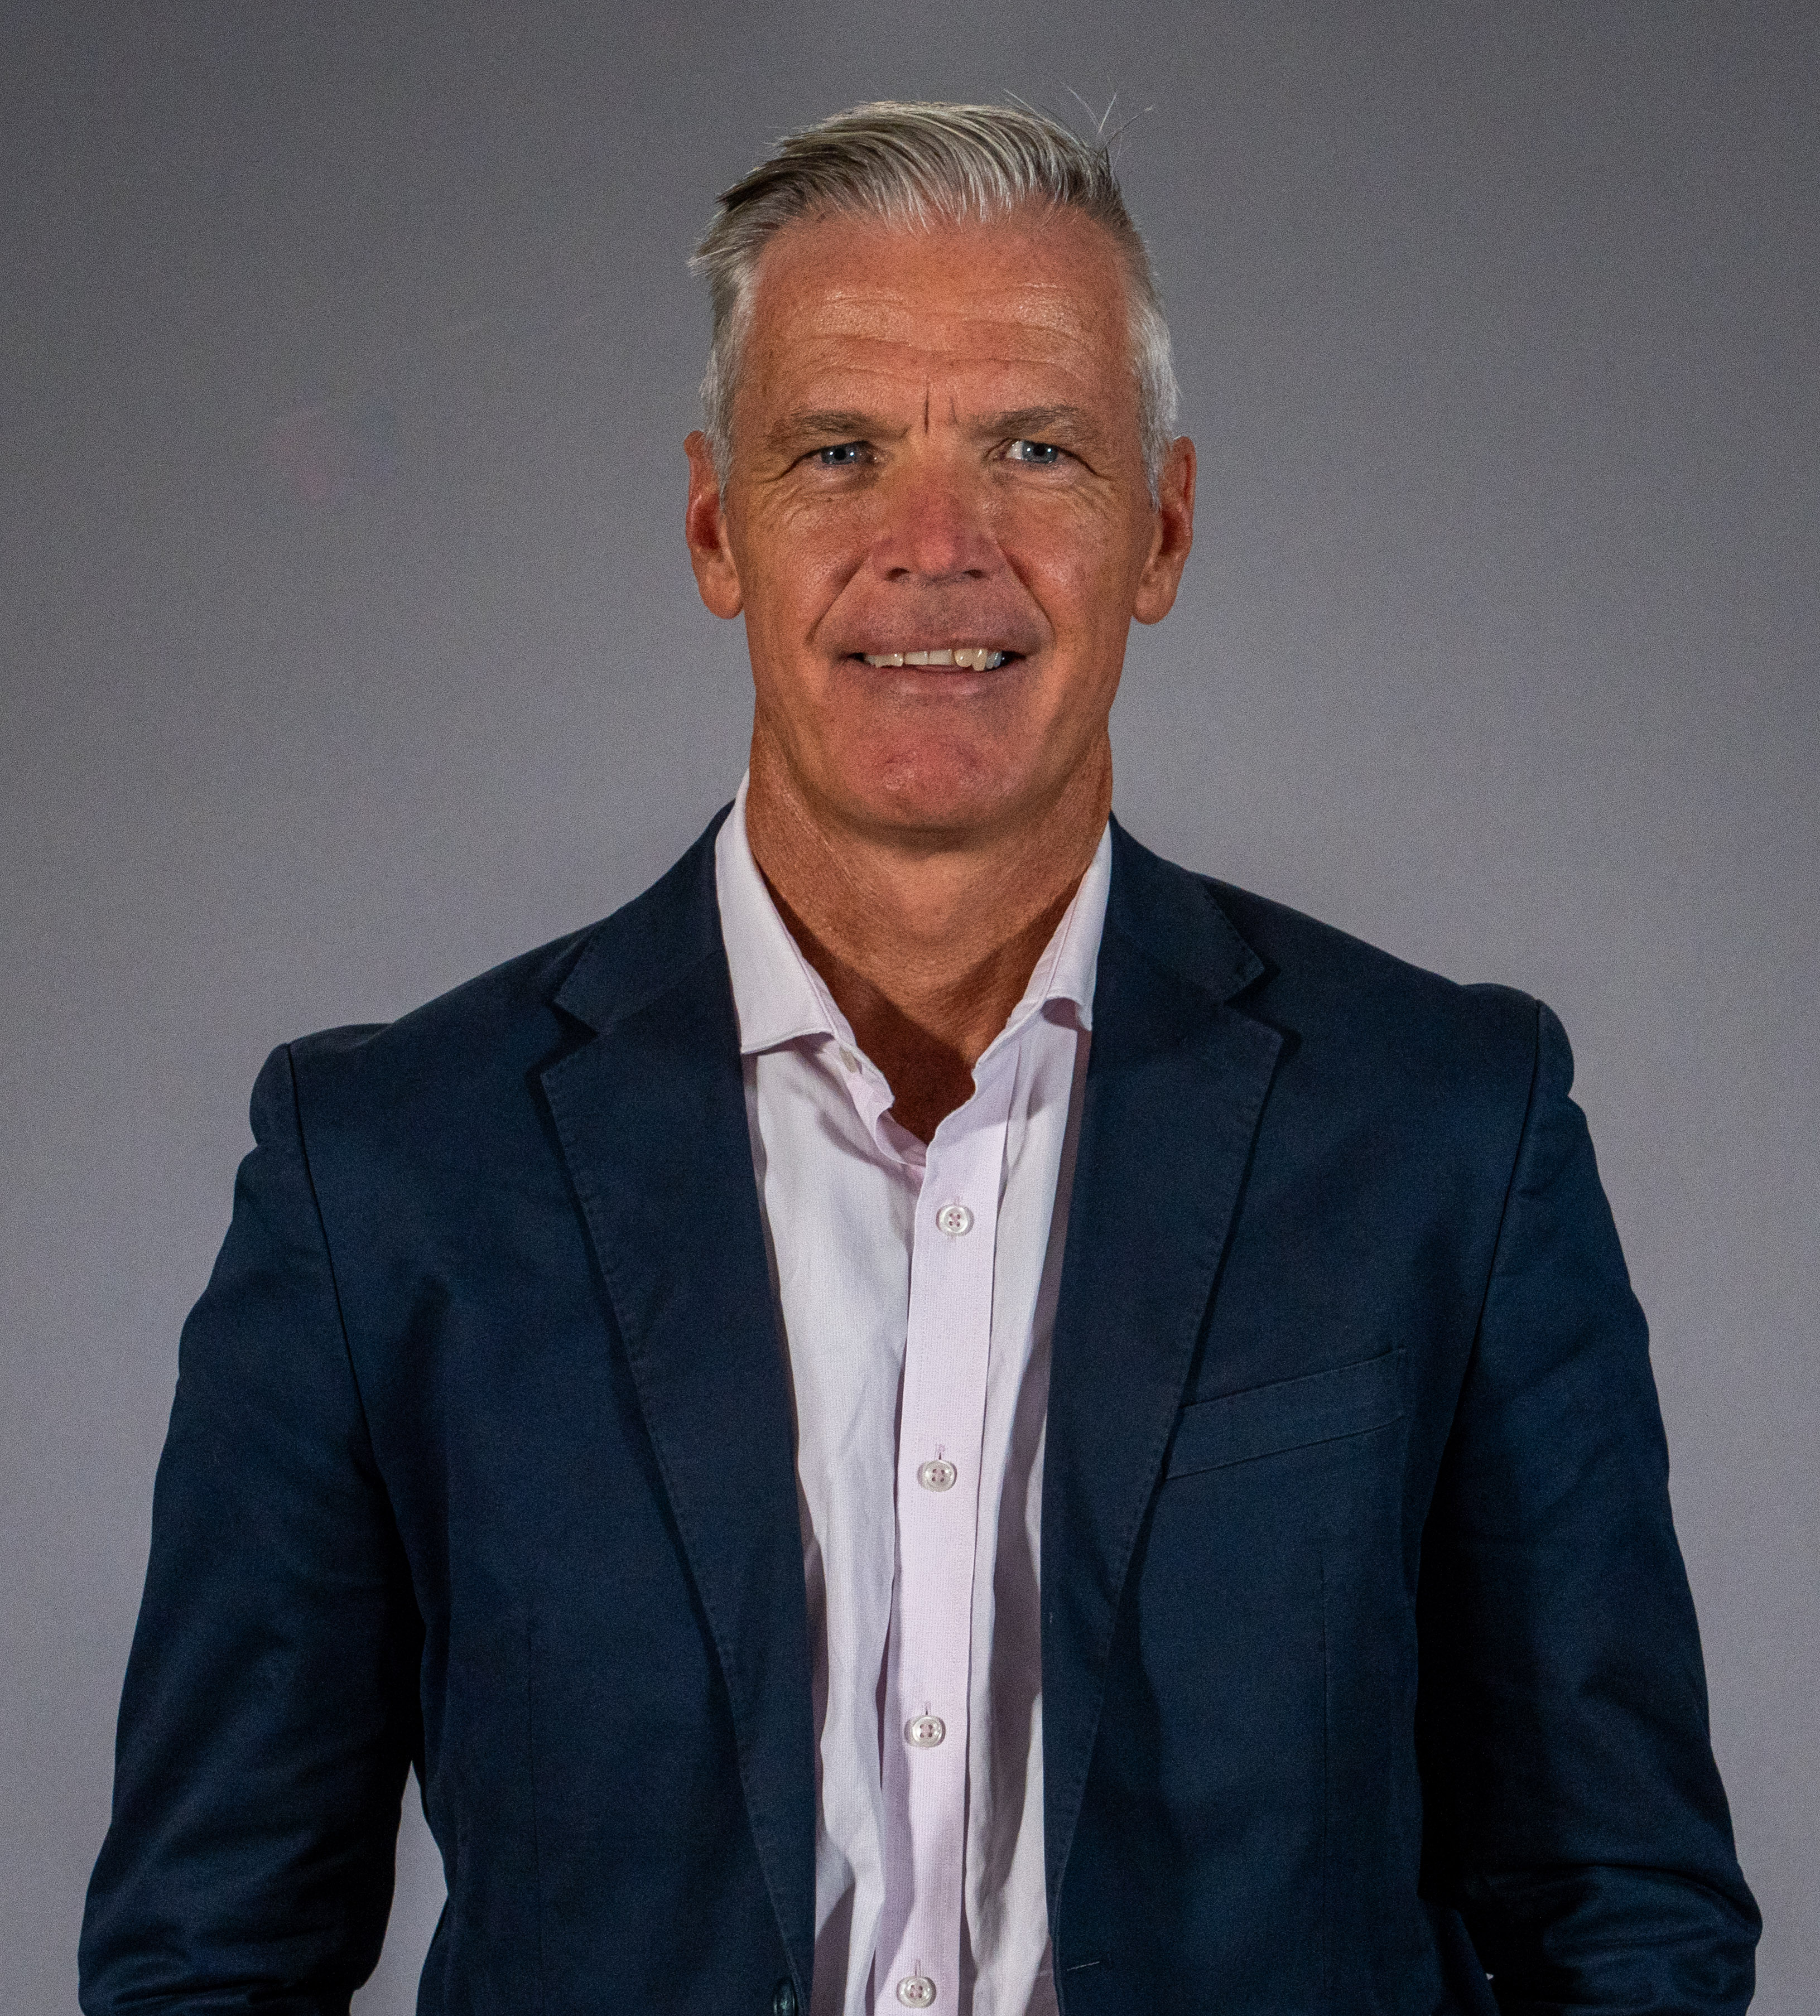

# OFFICE OVERVIEW

## Brief history of the AEIC

The *Australian Energy Infrastructure Commissioner* is an independent non-statutory role originally established in October 2015 by the Australian Government. The role at that time was known as the *National Wind Farm Commissioner* and was initiated by Recommendation 5 of the *2015 Senate Committee on Wind Turbines Interim Report.*

In November 2015, Andrew Dyer commenced his appointment to the role for an initial three-year term.

In October 2018, following an independent review of the role by the Climate Change Authority, the role was renewed for a further three years and expanded to include large-scale solar farms and energy storage facilities.

In March 2021, the Australian Government announced a further expansion to the role, to include new large-scale transmission projects. At this time the role was renamed to the *Australian Energy Infrastructure Commissioner*.

The Commissioner’s scope is set through Terms of Reference. These are available at Appendix A and on the Commissioner’s website at: [www.aeic.gov.au/about](http://www.aeic.gov.au/about)

## Time of transition

The inaugural Commissioner Andrew Dyer announced his retirement in March 2024 after 9 years in the role. Stakeholders were kept informed of this through direct engagement, media and via an update on the AEIC website:

* [Commissioner’s retirement letter to stakeholders](https://www.aeic.gov.au/commissioners-retirement-letter-stakeholders) (14 March 2024)

To enable a smooth transition and the important work of the AEIC to continue whilst recruitment to the ongoing role was done, an interim Commissioner was appointed from within the Department of Climate Change, Energy, the Environment and Water. John Sheldon was appointed as the interim Commissioner from 2 April 2024.

* [Interim commissioner arrangements letter to stakeholders](https://www.aeic.gov.au/interim-commissioner-arrangements-letter-stakeholders) (28 March 2024)

An extensive external recruitment process was undertaken to select a new Commissioner.   
On 23 September the appointment of Mr Tony Mahar as the new ongoing Commissioner was publicly announced, with a commencement date of 19 December 2024.

* [Minister's announcement - New energy infrastructure commissioner](https://minister.dcceew.gov.au/bowen/media-releases/new-energy-infrastructure-commissioner-facilitate-leading-practice-reliable-renewables-rollout) (23 Sept. 2024)

## Operational arrangements

The Commissioner is supported by a small team within the National Energy Transformation Division of the Department of Climate Change, Energy, the Environment, Climate and Water (DCCEEW).

The staffing, operational resources and other finances for the Commissioner’s Office are managed through the Department. In 2024, the nominal staffing for the Office comprised of an Executive Officer, a Complaints Officer, two Policy and Research Officers, and an Executive Assistant, as well as the interim Commissioner – although for much of the year there were vacancies being filled.

From the start of 2025 the team now includes:

***Assistant Commissioner*** *–* Works with and on behalf of the Commissioner. Provides strategic leadership on workplan and stakeholder engagement (including First Nations), complaints oversight/support, and departmental liaison.

***Executive Officer*** – supports the Commissioner and the team by providing operational leadership, including project-specific delivery oversight, supporting resourcing and governance needs.

***Executive Assistant*** *–* manages the Commissioner’s diary and travel, the 1800 contact number and the Commissioner’s correspondence.

***Case Handling Team (x2)*** *–* manages day-to-day handling of enquiries and complaints, including liaising with complainants, proponents and regulators, and escalating to the Commissioner and Assistant

***Communications and Policy Team (x2)*** – manages AEIC communications (including website), support with issue specific background information and research, and manages officer level stakeholder engagement.

## Other resourcing changes

In 2024 the Melbourne-based AEIC staff moved with the DCCEEW regional office from temporary accommodation at 2 Lonsdale St Melbourne to new office accommodation at 500 Bourke St Melbourne.

The AEIC team also participated in the Department’s wider *Digital Connect* migration, with all key systems fully transitioned to DCCEEW-managed IT environments. This provides a more stable and consistent records management system for our work.

## Contact details

The Office of the Australian Energy Infrastructure Commissioner can be contacted via:

Telephone (toll-free): 1800 656 395

Email: [aeic@aeic.gov.au](mailto:aeic@aeic.gov.au)

Post: Australian Energy Infrastructure Commissioner

PO Box 24434

MELBOURNE VIC 3001

# CASE DATA

## Helping communities get useful information and practical outcomes

We continue to provide an independent pathway to help community on project specific complaints and enquiries.

In 2024 we recorded our 1000th distinct case since the Commissioner’s role was first created in 2015. But this quantitative data only provides a partial picture of the public value of this case-handling function.

Helping to resolve project specific complaints and enquiries is a core role for us.

We do this by bringing the right people together, facilitating conversations and providing our view and recommendations on constructive ways to get good outcomes.

We make sure we understand the key concerns of the complaint, what practical outcomes are being sought and whether these are within our ability to deliver.

This is outlined in our *Complaint Handling Policy* and *Information Handling Policy*, both of which are available on our website at: <https://www.aeic.gov.au/making-a-complaint>

## Total case activity in 2024

We logged 152 new cases in 2024, making it our third busiest year.

The two years with more new cases, 2020 and 2021, coincided with the emergence of community concerns with new large-scale transmission projects and when these were added to our scope.

Most cases in 2024 were from Victoria, aligning with the significant growth in the renewables sector and a small number of proposals with high levels of community concern. There is also potential that the role of the AEIC is less well known in some jurisdictions, and ensuring an increase in the awareness and accessibility of the AEIC will be a focus for 2025.

###### **Figure 1**: Percentage of new cases in 2024 by State and Territory (excludes general enquiries)

Figure shows the percentage of new cases in 2024 by jurisdiction.  

ACT is zero, New South Wales is 13%, Northern Territory is zero, Queensland is 4%, South Australia is 4%, Tasmania is 2%, Victoria is 77% and West Australia is 2%

In 2024 wind farm related complaints were the clear area of greatest concern, with half of these attributed to a specific proposal in Victoria.

###### **Figure 2**: Percentage of new cases in 2024 by Asset type Pie Graph showing percentage of new cases in 2024 by asset type. Wind energy 66%, Transmission 11%, Storage 2%, Solar Farms 12% and general enquiries 9%

In many situations, we receive multiple complaints about the same proposed project:

* Of the **66%** related to wind farms, there were **100** cases over **33** projects
* Of the **12%** related to solar farms, there were **18** cases over **9** projects
* Of the **11%** related to transmission projects, there were **17** cases over **4** projects
* Of the **2%** citing an energy storage facility, there were **3** cases over **3** projects
* The **9%** of general inquiries involved **14** cases that did not specify a particular project.

During 2024, the Office formally closed 155 distinct cases, after an average of 102 days per case. This is a limited measure of case-handling outcomes and efficiencies. Some cases are quite simple and quick to resolve. Many are complex or long term due to the timeframes renewable proposals operate over, or have been left “open” to facilitate ongoing monitoring. We are looking at better ways to measure case resolution for future reports.

Some cases carry over from previous reporting years and continue into future reporting years. Occasionally a closed case is re-opened when new information comes to us. Allowing for the   
38 cases that were open as of 1 January 2024, and the four cases that were re-opened in that calendar year, total case activity in 2024 would be 194 cases.

Simple telephone or email enquiries that can be immediately answered also have not necessarily been formally registered as a case.

## Continuation of key trends

Key trends noted in previous Annual Reports have continued in 2024:

* Case numbers in-general have trended upwards since 2015
* The diversity and complexity of cases has increased, with us generally receiving complaints about a larger number of different projects and asset types, rather than numerous complaints about specific proposals
* Most complaints received are about proposed, rather than operating, projects; in previous reports it has been suggested that this may be because concerns have been addressed during development, planning and construction, or they relate to a perceived issue that did not materialise. But there is also potential for complaint fatigue or proposals that did not proceed to development and further exploration on this would be useful; and
* Most cases are resolved at an initial complaint enquiry stage. That is, by the Office providing relevant tailored information to empower direct dialogue with project proponents and/or government planning authorities.

###### **Figure 3**: Yearly cases by Asset type over time

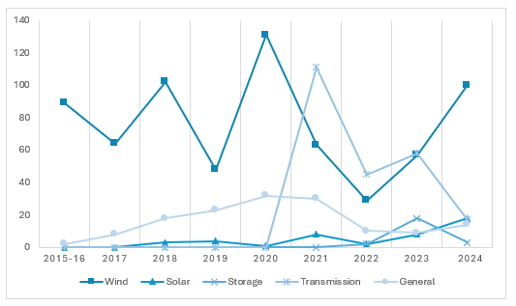

## Themes and emerging insights

For each new case received we record key issues raised, and a single case may thus raise multiple complaint issues. This helps to indicate trends and areas where we may focus more strategic work. As there is an inevitable degree of professional judgement in this process, the following data needs to be reviewed with that caveat in mind.

Across all asset types and jurisdictions, in 2024 the four most common issues raised in new cases in 2024 were:

* Community Engagement (**46%** of the time,or **70** cases)
* Safety (**33%** of the time,or **50** cases)
* Natural Environment (**32%** of the time,or **49** cases)
* Amenity (**31%** of the time,or **47** cases)

There are some distinct variations between asset types, shown further below.

###### **Figure 4**: 2024 new cases key issues as a percentage of complaints

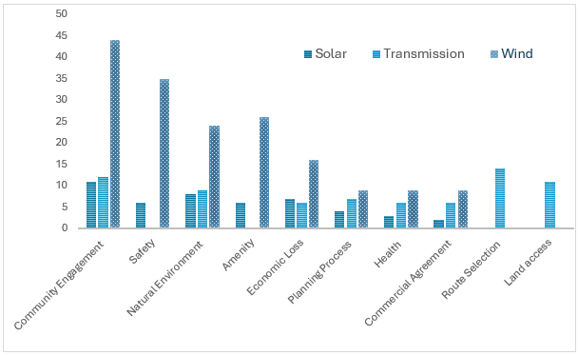

#### Community Engagement

Community engagement continues to be a key concern. Through cases and direct community engagement, we hear a recurring theme of a sense of communities not being informed, respected and at worst being patronised, or that engagement is a tick-the-box exercise rather than a meaningful one.

This tells us that proponents still have a long way to go. But it is more complex than that, with connection and interaction across themes.

Some companies are choosing to go out early with information on new proposals, trying to get ahead of community rumours or placing potential landowners in uncomfortable confidentiality situations. Whilst this may be done with good intent, it can lead to dissatisfaction with extended timeframes before the detailed information the community wants is available, or formal approval processes begin.

Community also express dissatisfaction with engagement through formal approval processes, and this cannot be fairly laid at the feet of proponents. Relevant regulators, and planning approval bodies also need to consider best practice public information and community engagement. It is not enough to simply open a portal to receive comments once an application is received, and not provide clear public guidance on the goals, roles and other process requirements, or not provide responses or timing updates for long periods of time.

Planning processes can be very drawn out and vary between jurisdictions and even different proposal types within jurisdictions. This can lead to further community fatigue and disengagement, confusion and a feeling of not being truly engaged or heard in the process. Conversely, some “fast track” approval processes designed to facilitate a quicker “yes or no” outcome can be viewed by complainants in a negative light, as lacking robustness or suggesting a project is already a “done deal”.

Sometimes we find it hard to find relevant and up to date information, so community is likely to as well. Project and government websites are important for allowing the community to access good information in their own time, but are variable in quality and sometimes outdated in information.

#### Safety

We are hearing increasing community concerns about safety in both planning and operational stages for generation assets such as wind farms and solar farms, and for storage such as batteries.

In the planning stages, a common safety concern raised is the risk of fire. This can be from fear of a fire starting from facilities or spreading into them, including concerns about possible harmful emissions and the ability of emergency services to adequately respond. These concerns are heightened in fire-prone areas, which are common in rural areas where many new proposals are located. Lack of understanding of (or trust in) the regulatory approval and future compliance monitoring processes can further exacerbate these concerns.

For operating facilities, safety concerns have also arisen with recent incidents at some wind energy facilities. Prompt regulatory follow up and information sharing on this can help respond to concerns.

Where facilities, particular wind turbines, are located in close proximity to airfields then aviation safety may be raised as a concern. There are complex technical requirements for aviation safety assessments and having these completed and the information shared with stakeholders with enough time for any clarification is important.

Safety concerns also encompass transport, in particular rural roads. The change in volume, type and timing of traffic movements, combined with the condition of roads before, during and after construction lead to community concerns about increased risk of accidents for local users.

#### Natural Environment

Community members often raise concerns over impacts to natural environments such as birdlife, wetlands and heritage areas.

There is again a lack of understanding of or trust in the regulatory approval processes that assess these aspects. Communities report that they do not feel that their local knowledge is valued and respected in the process, where outside experts or consultants are preparing approval documents. They feel that they carry the burden of having to prove potential impacts.

Impact to birdlife is a frequent concern – for wind facilities this is potential impact with blades, for transmission it is for disruption of nesting areas.

Construction impacts and vegetation clearing more broadly are also raised in many complaints.

#### Amenity

Visual amenity is a primary concern for many neighbouring landholders but also for broader community groups, First Nations peoples and some local governments.

The size and scale of facilities continues to grow – larger solar farms and taller wind turbines – exacerbating this. There are limited resolutions to some of these concerns – things like tree screenings can only go so far. Successful use of site specific montages can be helpful in giving a realistic view of what a future landscape may be, but need to be done with realism to be helpful in setting expectations.

Emerging technologies such as augmented reality and virtual reality technologies can enhance existing methods for communicating the impacts of new large-scale infrastructure to impacted residents. Early feedback from companies suggests only limited or patchy deployment of these technologies in Australia. The AEIC is continuing to investigate the utility of these technologies to support community engagement in Australia.

For both planned and operating wind energy facilities, noise and shadow flicker are common amenity concerns. Noise assessments for these facilities are technically complex, and this can make it hard for community to have confidence in both approval and post-construction assessments

#### Other complaint issue themes

Some other themes emerging in case engagement in 2024, include:

* Following a distinct cluster of cases in 2023 about proposed and declared offshore wind areas and new pumped hydro storage projects, no new cases were recorded against these asset types in 2024 (although the Office is still handling and/or monitoring some cases involving proposed pumped hydro facilities).
* New cases for transmission proposals were lower, but we recognise ongoing strong opposition in certain stretches of some routes and continue to manage some long term cases and concerns.
* Land access is in some instances not done well – people feeling like they have lost control over their own property and loss of confidence through “preventable complaints” such as leaving gates open.
* Across all asset types, perceived risks in relation to fire safety, public insurance, land valuations, tax status of different compensation and benefit payments, and the loss of agricultural land, continue to be raised by potential neighbours and other community members.
* Planning processes, particularly buffer zones for new wind and solar farms, is an issue that is consistently raised as a matter of concern by impacted residents. Finding this information, which is different for each state and territory where it does exist, can be challenging.
* More broadly, the complexity of planning processes (including both environmental assessment and development/construction approvals) is another driver of concern – often the community don’t know who to contact at what stage of a project in their state.
* A new recently raised concern is the extent to which project planning and impact assessment considers the particular circumstances of neurodivergent members of the community. Early work indicates that there is little information available on these impacts and we are looking into this further.
* With some early assets now reaching end of life, decommissioning has again come up as a concern for community. Clarity on roles and responsibilities, including costs, as well as disposal options and the markets for recycling are continuing to be raised.

**AEIC case flow process and terminology**

Incoming calls and correspondence to the Commissioner, direct and from 3rd party referrals from Members of Parliament and other organisations, are logged in our complaints system as **cases** through an “**enquiry**” stage.

Complaint cases move through different stages through to ultimately being closed. Each case is approached in the best way for the specific concerns.

**Complaint cases** *stages include* **complaint accepted, complaint not accepted**, **referral**, **recommendation,** and **conciliation** stages.

**General inquiries** are cases that are not a formal complaint about a particular project. They typically involve community members seeking more general information to address their concerns.

# STAKEHOLDER ENGAGEMENT

## Building bridges and making connections

In delivering the three core functions of the Commissioner’s role – community case-handling, the dissemination of trusted information, and the promotion of best practices – the AEIC team meet and work with a wide range of stakeholders.

By building trusted relationships, the AEIC gathers diverse perspectives and identifies practical and enduring pathways to resolving project-specific and systemic issues.

Across multiple Commissioners and the Office staff, in 2024 we participated in more than   
330 separate in-person and videoconference meetings. Some of these meetings were relatively informal discussions, while others involved ongoing membership of key governance forums and invited presentations at different events.

Stakeholders included both concerned and supportive local community members and regional groups, individual First Nations organisations, industry representatives (from individual project proponents through to peak bodies), various technical experts and specialist organisations, and the full range of federal, state and local governments.

## Meeting people where they are

Since the inception of the Commissioner’s role, site visits have provided a valuable opportunity to meet with concerned residents and directly experience operational activities in affected areas.   
In several cases, mainly driven by case handling activities or ongoing systemic matters, some project locations have been visited multiple times.

In-person visits to landholders who are potentially affected by proposed transmission routes continue to highlight issues relating to land access, easement acquisition, and the importance of resolving route options and providing effective collateral materials (including fair and reasonable commercial agreements, and project fact sheets that present key information from the landholder and community perspective).

The issues raised at site visits and in meetings with community and landholders help better inform our discussions with industry and government and our ability to provide “on the ground” feedback and insights. They also help us to better demonstrate empathy and accurately articulate community concerns and perspectives, as well as contributing to better outcomes in the resolution of issues.

#### Case study: VNI West transmission corridor route visit (Vic)

Between 5 and 7 June 2024 the interim Commissioner and the AEIC Executive Officer participated in a series of in-person meetings with community members regarding the VNI West transmission project in north-west Victoria. This three-day trip included community members and landholders with diverse views on the project.

Observations from this trip included:

* Uncertainty about the final location of the VNI-West route – and the process for determining the route – has been a driver of anxiety among landholders within the area of interest.
* There are a range of views about the potential impacts and benefits of the project and the energy transition more broadly.
* Where some landholders are seeking to benefit from the project and are interested in hosting renewable infrastructure on their properties, others are very concerned about the project’s impacts on their properties and so are strongly opposed to the project.
* Other local landholders are also worried that VNI-West could attract renewable energy projects to the region, and that future projects could impact on agricultural activities.
* Some landholders also expressed the view that the regions are carrying the burden of the transition but receive inadequate benefits. For example, regional power reliability was raised as a concern in some areas, which reinforced the view that the regions are being left out.

These 2024 observations are consistent with previous AEIC commentary on the importance of good community engagement, in addition to ensuring that clear, consistent and fair processes that are well communicated and understood. They also highlight the importance of ensuring regional communities are benefitting from projects and that communities are involved in shaping the benefits.

Across 2024, other notable travel by the AEIC team included:

* Visiting part of the Project Energy Connect transmission route and participating in land engagement training in Wagga Wagga, NSW, in July
* Attending the Surat Basin Energy Summit in Dalby, Qld, in August
* Visiting community members about a proposed solar farm in Yass, NSW, in August
* Multiple trips to meet community members with concerns about a proposed wind farm in the Lethbridge area of Victoria, in August and September
* Meeting landholders to hear about their experiences with the VNI-West (Vic) and Western Renewables Link project, in north-west Victoria and the Melton area respectively in September
* Attending a community meeting about a proposed solar farm in north-east Victoria, October

## Project and systems-level engagement

When we receive a new community complaint about a project or proponent, or in response to direct engagement, we may seek informal briefings on proposed projects from proponents. These briefings provide an opportunity to better understand projects from the proponent’s perspective, and to make suggestions regarding their community engagement and other project planning based on our experiences with landholders, neighbours and the broader community.

In 2024 the AEIC team also continued to liaise directly with project teams on nationally significant transmission developments, as well as state and federal government officials across the energy, planning, regional development and environment portfolios.

More broadly, systemic insights from our case-handling and stakeholder engagement contribute to the AEIC’s ongoing participation (or observer status) in forums such as the:

* Rewiring the Nation (RTN) Advisory Committee
* Victorian Minister’s Monthly VNI-West / WRL Joint Oversight Meeting
* DCCEEW Stakeholder Reference Group on Renewable Energy Developer Rating Scheme
* Energy Charter Community Outcomes Group on Evaluating Transmission Undergrounding
* DCCEEW Quarterly Portfolio Agency Heads Meeting

Our input and feedback in these forums provide an additional independent and balanced perspective in discussions, which ultimately promotes stronger systemic decision-making and more sustainable outcomes.

## Other public platforms

The tabling and publishing on 4 July 2024 of the *AEIC 2023 Annual Report to Australian Parliament*, along with the interim Commissioner’s appearance on 4 November 2024 before the Senate Environmental and Communications Committee’s Supplementary Budget Estimates hearings, were important milestones for the AEIC team. More than simply operational accountability requirements, these processes are important opportunities for putting our ongoing activities and emerging priorities on the public record for shared reference.

Across the year, the AEIC team also gave conference and workshop presentations. Topics discussed at these events included the Community Engagement Review, social licence and community engagement for offshore wind developments, the local impacts and regional development opportunities from renewable energy infrastructure projects, and available resources for landholders and community members.

* AEIC staff – panellist – *Australian Offshore Wind Energy Conference* (Melbourne, Vic, 27 February 2024)
* Andrew Dyer – panellist – *Energy Networks Australia Conference*(Adelaide, SA, 19-21 March 2024)
* AEIC staff – webinar presentation* – *Landowner seminar on renewable energy projects* (Hume region, Vic, 26 June 2024)
* John Sheldon – panellist– *Surat Basin Energy Summit* (Dalby, Qld, 5-7 August 2024)
* John Sheldon and AEIC staff *–* presenter/participant – *Stakeholder workshops on merit criteria in the Capacity Investment Scheme* (Canberra, ACT, 22 August 2024 and Melbourne, Vic, 19 September 2024)
* John Sheldon – presentation – *Natural Resource Management (NRM) Regions Australia National CEOs Forum* (Canberra, ACT, 5 September 2024)
* John Sheldon *–* panellist* *– Regional Development Australia (RDA) National Forum* (Busselton, WA, 29 October 2024)
* John Sheldon– presentation – *National NRM Regions Forum*(Canberra, ACT, 20 November 2024)

( * indicates online participation)

# TRANSPARENCY AND BEST PRACTICE

The AEIC team’s activities to promote increased transparency and better practice in the development and management of renewable energy infrastructure are quite diverse.

This workstream includes facilitating the dissemination of credible information about specific projects and related systemic issues (for example, through our website). It also involves contributing to the development of new resources and overarching frameworks, through collaborative and direct engagement with industry, governments at all levels, and other stakeholders.

While staffing changes and recruitment processes somewhat constrained our proactive efforts on this workstream in 2024, the AEIC team was nonetheless able to productively contribute to multiple sector-wide initiatives. These efforts play a valuable role in promoting information-sharing across projects, proponents, regions, sectors and jurisdictions.

## Community Engagement Review (2023)

On 2 February 2024 Minister Bowen released the *Community Engagement Review* report, along with the Australian Government’s Initial Response that accepted in-principle all of the Review’s recommendations. The recommendations, when implemented by relevant jurisdictions, are designed to achieve ongoing excellence in community engagement and, more broadly, excellence in the execution of the energy transition. An overview of the recommendations can be found at **Appendix** **B** and the report is available on the Commissioner’s website.

The Commissioner subsequently attended the meeting of the Energy and Climate Change Ministerial Council (ECMC) on 1 March 2024, where Ministers agreed to consider actions to address the recommendations, including *“as a priority action … working together on the options for a national developer rating scheme”*.

Implementation of the report’s recommendations involves distinct responsibilities across different levels of government. Collaborative work in 2024 through the ECMC has laid the foundations for accelerating the implementation of the recommendations in 2025. In particular, the 19 July 2024 meeting of the ECMC released a formal response agreeing (or agreeing in-principle) to all nine recommendations, along with a 78 page, 172 item stocktake of jurisdictional actions currently underway.[1]

### *The AEIC’s role to-date and 2024 activities*

Primary responsibility for monitoring the implementation of governments’ commitments in response to the report lies with the ECMC. To support these efforts, in 2024 the interim Commissioner continuously sought and shared views from a range of community members, industry representatives, energy and water ombudsman, and governments regarding the review’s recommendations. This included making connections between various stakeholders and the Department, supporting the Energy Charter’s Landholder Lived Experience Panel, and observing the Stakeholder Reference Group for the development of the proposed developer rating scheme.

### *Next steps in 2025*

The AEIC team will actively pursue and seek collaboration to progress the recommendations of the *Community Engagement Review,* consistent with the Commissioner’s updated Terms of Reference:

*The Commissioner will assist the Australian Government to implement the recommendations of the AEIC Community Engagement Review, in line with any advice in relation to those recommendations made by the Energy and Climate Change Ministerial Council.*

It is encouraging that, at the time of writing, DCCEEW is working to appoint a qualified and experienced independent body to design, develop, implement and operate a developer rating scheme (in response to recommendation 1).

This includes seeking registrations of interest from renewable energy developers to participate in the scheme’s design and testing through a Renewable Energy Businesses Participation Panel.[2]

## Other practical advice, formal input, and collaborative initiatives

The Commissioner’s website – at [www.aeic.gov.au](http://www.aeic.gov.au) – is an essential ongoing enabler of our efforts to promote transparency and best practice. It provides links to a range of project-specific and asset type information, including various guidance resources and information about our role, policies, and how to seek further assistance (or make a complaint).

During 2024, the AEIC team also provided ongoing input and feedback on a range of industry, community and government “better practice” initiatives, guidelines, resources and/or frameworks, including:

* Contributing to the development of the National Guidelines on Community Engagement and Benefits for Electricity Transmission Projects (July 2024)[3]
* Consulting on the development of the Understanding Australian Transmission Projects Resource Hub[4]
* Updates by EWOV and Victorian transmission project proponents on their current/new complaints management processes following the finalisation of a new Land Access Code of Practice in Victoria.

# APPENDIX A: Terms of Reference

**Australian Energy Infrastructure Commissioner (2021-25)**

The role of the Australian Energy Infrastructure Commissioner was announced by the Australian Government on 26 March 2021 expanding and replacing the role of the existing National Wind Farm Commissioner.

The Commissioner will work collaboratively with all levels of government, scientists, experts, industry and the community to resolve complaints from community members about proposed and operational wind farms, large scale solar farms (5 MW or more), energy storage facilities, such as pumped hydro and large-scale batteries (1 MW or more) and new major transmission projects.

The Commissioner will refer complaints about wind farms, large scale solar farms, storage facilities and new major transmission projects to the relevant respondent or authority and help ensure they are properly addressed.

The Commissioner will lead efforts to promote best practices, information availability, and provide a central, trusted source for dissemination of information.

The Commissioner, supported by the Australian Government Department of Climate Change, Energy, the Environment and Water, will report to the Minister for Climate Change and Energy and provide an Annual Report to the Australian Parliament on delivering against these Terms of Reference. The Commissioner may also, by agreement with the Minister, lead reviews relevant to the Commissioner's role and expertise.

The Commissioner’s role will not duplicate or override the important statutory responsibilities of other jurisdictions, such as those relating to the planning and approval of wind farms, large scale solar farms, storage facilities and new major transmission projects.

The role of the Commissioner has been extended until 31 October 2025. The role will be   
re-evaluated by the Australian Government prior to that date.

**Please note:** *the current AEIC Terms of Reference (2024-27) were updated on the appointment of Tony Mahar, effective 19 December 2024, and are available online at* [*www.aeic.gov.au*](http://www.aeic.gov.au)

# APPENDIX B: Excerpts from the *Community Engagement Review* (2023)

***Theme 1: Developer performance and selection***

Improve community engagement by motivating developers to achieve best practice and only selecting reputable developers for new project developments.

**Recommendation 1.** The Minister to initiate a process to appoint an independent body to design, develop, implement and operate a developer rating scheme.

**Recommendation 2.** The commonwealth, state and territory governments to continue their deployment of programs to better plan and control development of new generation and transmission projects.

***Theme 2: Selecting the best sites***

Reduce and eliminate unnecessary community engagement by selecting the best project sites and avoiding poor and inappropriate sites.

**Recommendation 3.** State and territory governments to support and expedite sourcing information that is necessary for contemporary land use planning.

***Theme 3: Reform environmental and planning approvals***

Reduce and minimise the need for elongated community engagement by re-engineering planning and environmental assessment and approval processes.

**Recommendation 4.** To progress, complete and expedite the deployment of process reforms currently being contemplated by the jurisdictions, which will materially improve processes and help reduce the time needed to obtain planning and environmental approvals for projects.

***Theme 4: Complaint management***

Reduce unresolved and lengthy complaints by ensuring best practice complaint handling, backed up with a new, relevant ombudsman scheme in each state.

**Recommendation 5.** State and, where applicable, territory governments to establish and implement a new ombudsman function focussed on handling complaints about renewable energy generation, large-scale storage and new transmission infrastructure.

***Theme 5: Messaging and governance***

Improve community understanding of the need for the transition, including what is to be deployed in their region as well as where, when and why. Ensure appropriate governance is in place to manage the broader impacts of the transition as well as oversight of projects of national significance.

**Recommendation 6.** The Minister to initiate a process for the development and execution of a communications program that provides local communities with a clear narrative about the pragmatic reasons for the energy transition.

**Recommendation 7.** The Commonwealth to work with state and territory governments to implement appropriate oversight governance arrangements that should be in place for transition projects of national significance and to provide a cross-discipline, whole-of-government approach to the energy transition.

***Theme 6: Coordinated economic development and community benefits***

Improve acceptance of the transition changes and impacts by engaging the community to identify opportunities and enable sustainable benefit sharing. These opportunities include local economic development in conjunction with numerous other opportunities that will benefit the broader community.

**Recommendation 8.** The Commonwealth to work with jurisdictions to ensure appropriate arrangements exist at state, territory and national levels to provide a cross-discipline, whole-of-government approach to identify, cultivate and generate tangible economic and investment attraction opportunities for regional businesses, including First Nations peoples and their enterprises.

**Recommendation 9.** States, territories and local governments to encourage local community groups to proactively identify opportunities for the broader community’s benefit, as well as to take ownership of sound opportunities to secure support and funding.

*Links to PDF and MS Word versions of the full report are available via the AEIC website at:*[Community Engagement Review Report](https://dcceew2.sharepoint.com/sites/DCCEEW-AEIC/5/03%20-%20Annual%20Report/AEIC%202024/Final%20versions/Community%20Engagement%20Review%20Report)

## Contact details

The Office of the Australian Energy Infrastructure Commissioner can be contacted via:

Telephone (toll-free): 1800 656 395

Email: [aeic@aeic.gov.au](mailto:aeic@aeic.gov.au)

Post: Australian Energy Infrastructure Commissioner

PO Box 24434

MELBOURNE VIC 3001

1. Available online at: [ECMC Response to Community Engagement Review](https://www.energy.gov.au/energy-and-climate-change-ministerial-council/energy-ministers-publications/response-to-aeic-community-engagement-review) (Accessed 11 March 2025).
2. For more detail, please see: [DCCEEW Developer Rating Scheme ROI Process](https://consult.dcceew.gov.au/renewable-energy-developer-rating-scheme-developer-roi-process) (Accessed 12 March 2025).
3. Available online at: [National Guidelines Community Engagement and Benefits for Electricity Transmission Projects](https://www.energy.gov.au/sites/default/files/2024-07/national-guidelines-community-engagement-benefits-electricity-transmission-projects.pdf) (Accessed 12 March 2025).
4. Available online at: [Understanding Australian Transmission Projects Resource Hub](https://understanding-australian-transmission-projects.com/) (Accessed 12 March 2025).