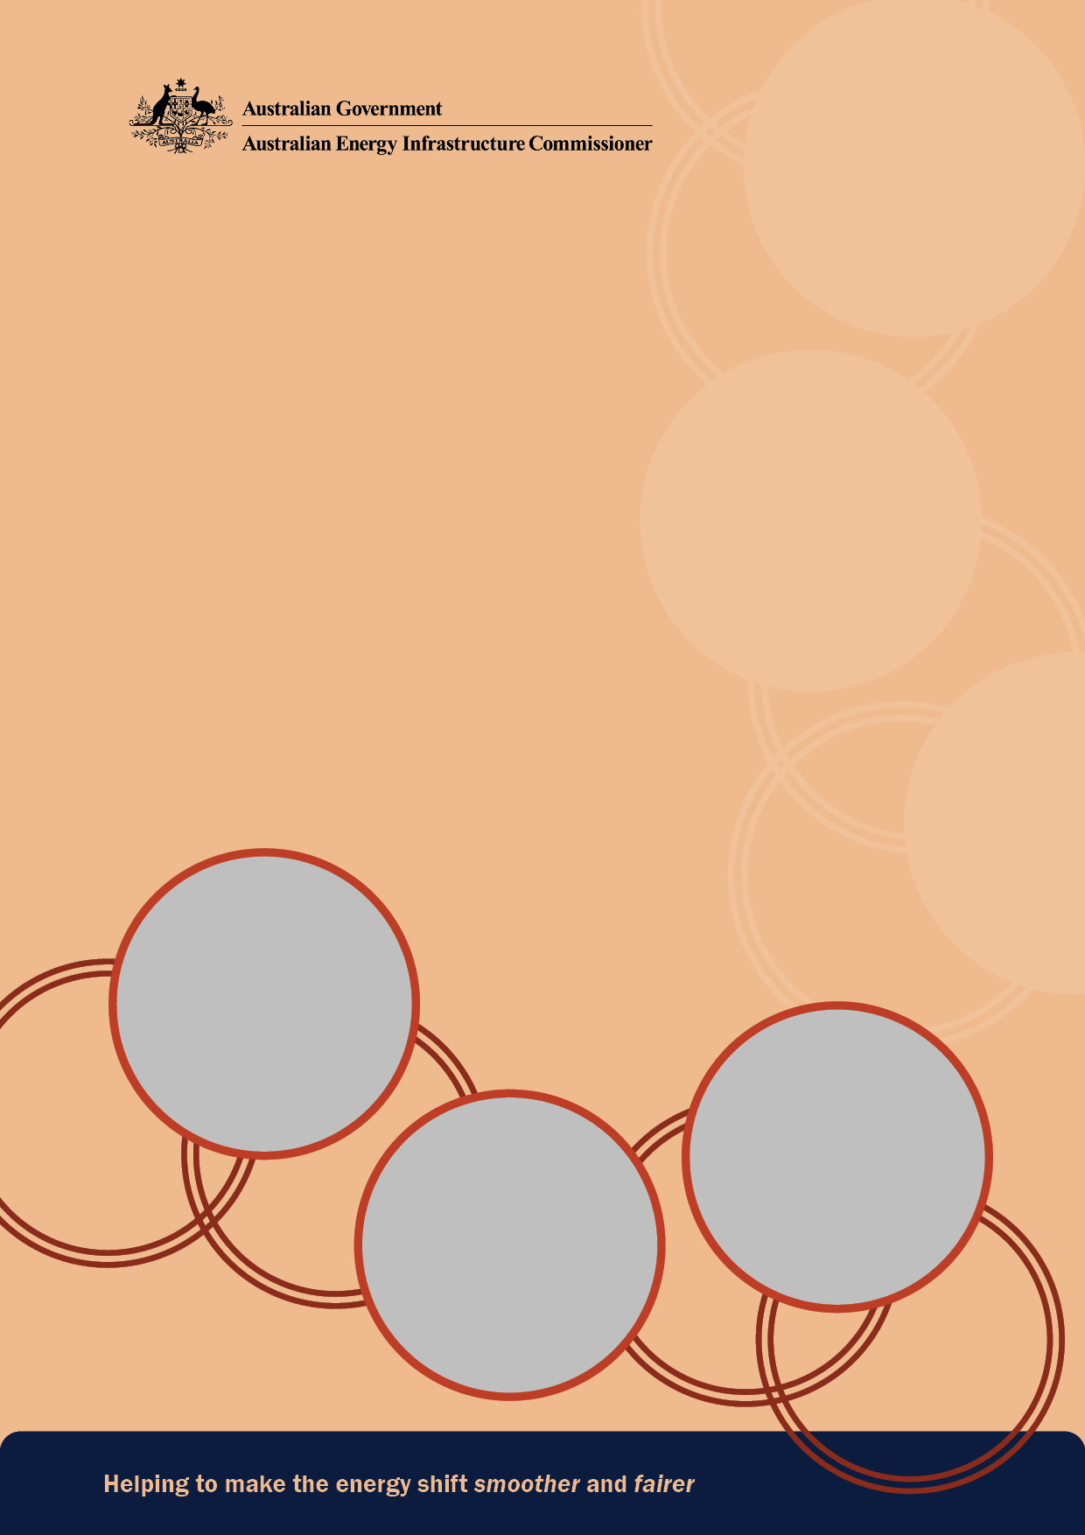
AEIC 2025 Annual Report
to the Australian Parliament
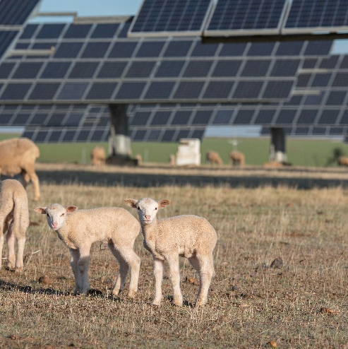
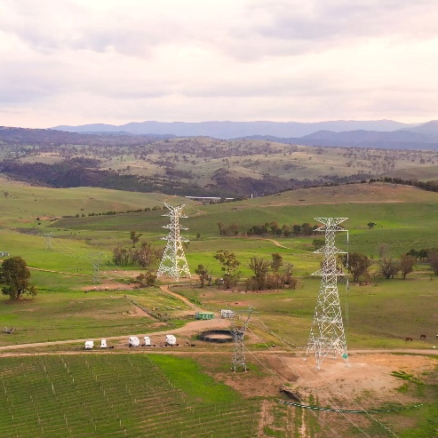
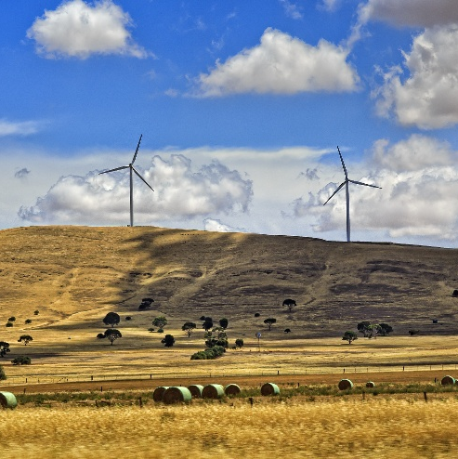

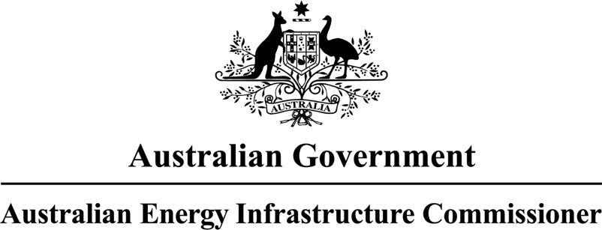

Annual Report
to the Parliament of Australia

Year ending 31 December 2025

© Commonwealth of Australia 2026
ISBN: 978-1-7635223-2-9 [Print]
ISBN: 978-1-7635223-3-6 [Digital]

Ownership of intellectual property rights
Unless otherwise noted, copyright (and any other intellectual property rights) in this publication is owned by the Commonwealth of Australia (referred to as the Commonwealth).

Creative Commons licence
All material in this publication is licensed under a Creative Commons Attribution 4.0 International Licence except content supplied by third parties, logos and the Commonwealth Coat of Arms.
Inquiries about the licence and any use of this document should be submitted via our online contact form.


Cataloguing data
This publication (and any material sourced from it) should be attributed as: AEIC (2025) Annual Report to the Australian Parliament, Canberra, March. CC BY 4.0.
This publication is available at www.aeic.gov.au.
Office of the Australian Energy Infrastructure Commissioner
GPO Box 24434 Melbourne VIC 3001
Telephone 1800 656 395
Web www.aeic.gov.au

Disclaimer
The Australian Government acting through the Department of Climate Change, Energy, the Environment and Water has exercised due care and skill in preparing and compiling the information and data in this publication. Notwithstanding, the Department of Climate Change, Energy, the Environment and Water, its employees and advisers disclaim all liability, including liability for negligence and for any loss, damage, injury, expense or cost incurred by any person as a result of accessing, using or relying on any of the information or data in this publication to the maximum extent permitted by law.

Acknowledgement of Country
We acknowledge the Traditional Owners of Country throughout Australia and recognise their continuing connection to land, waters and culture. We pay our respects to their Elders past and present.

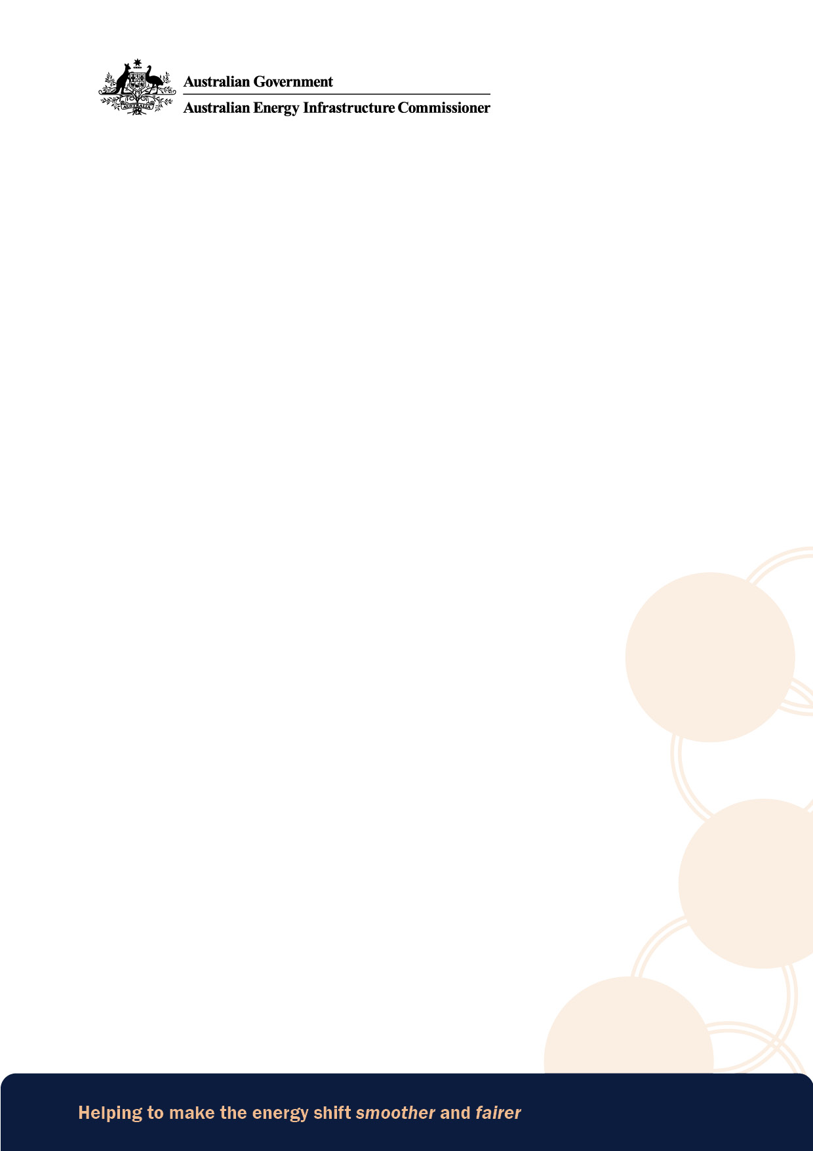

31 March 2026

The Hon Chris Bowen, MP
Minister for Climate Change and Energy
Parliament House
CANBERRA ACT 2600

Dear Minister
2025 Annual Report of the Office of the Australian Energy Infrastructure Commissioner
Pursuant to my Terms of Reference, I am pleased to provide the 2025 Annual Report to the Australian Parliament on the activities of the Office of the Australian Energy Infrastructure Commissioner.
This report covers the period of 1 January 2025 through to 31 December 2025.

Sincerely

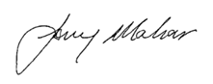

Anthony (Tony) Mahar
Australian Energy Infrastructure Commissioner

Contents
Contents 7
Commissioner’s introduction 8
Year in review 8
Year ahead 9
Community enquiries and complaints 10
Case information and insights 11
Stakeholder engagement 19
Parliamentary platforms 20
Media 21
Conferences and forums 21
Site visits, community meetings and targeted events 23
First Nations engagement 24
Information availability and best practice 26
Website and AEIC publications 27
Submissions and consultations 28
Community Engagement Review (2023) 32
Operational and strategic priorities in 2026 33
Appendices 35
Appendix A: AEIC terms of reference (2024–27) 35
Appendix B: Office history and current operational arrangements 36
Appendix C: Complaint issues and definitions 39
Appendix D: Excerpts from Community Engagement Review (2023) 41
Contact details 43

Commissioner’s introduction
I am pleased to deliver the tenth Annual Report to the Australian Parliament on the work of the Office of the Australian Energy Infrastructure Commissioner, which covers the first full calendar year of my appointment to this role (1 January 2025 to 31 December 2025).

Year in review
I took on this role because of my passion for supporting rural and regional communities, and working with industry, to make sure we get the best outcomes possible as part of the current energy shift. This also includes providing advice to governments on the implementation of the previous Commissioner’s Community Engagement Review.
In the last 12 months we have been active across the full range of our case resolution, stakeholder engagement and information availability and best practice functions.
My overall assessment after this first year is that the challenges are more complex and deeper than I had even imagined. Australia’s ongoing energy transition is nationwide and long-term, but it is also happening at an increasing pace and will affect different regions differently. Inevitably, it involves real disruptions and some uncertainty for communities, as it brings a lot of new things into the landscape – and change of this magnitude is never going to be easy.
There are no simple answers with these challenges. I am far from being an energy industry expert, but I have learnt in this past year that if anyone tells you there are simple solutions then they don’t understand the task or the operating environment.
It has been critical for me to listen and learn as much as possible – as a result, I had over
440 discrete external engagements in the year (and even more informal conversations). I have sat at kitchen tables and country halls, in cafes and offices, in boardrooms and council chambers and, of course, joined many online meetings.
At times it has been hard to hear some of the deeply personal experiences, but I do acknowledge and thank those people for trusting me and giving me such valuable perspectives. I also thank those in industry and government who have taken time to explain things in detail and offer a different perspective.
I started the year with a firm conviction that energy infrastructure projects should be seen as investments – not just in energy production but in the development of vibrant regional economies. This can only happen if local communities are respected, engaged and empowered throughout the process. I remain firmly of the view that the investment can be good for the energy transition and for communities.
I have seen some genuine improvement in commitment and flexibility from companies in the sector which is encouraging. I have requested and joined with senior executives to meet with community members on their properties, in their towns to have face-to-face discussions to demonstrate they understand the concerns in the community. I have seen energy developers make changes in response to community concerns and input and improve benefit sharing; this good behaviour should be acknowledged and built on. I have, however, also seen some activity that is below what I would call best practice and needed to be called out and improved. There is much to do, and I look forward to working collaboratively across the sector to make the energy shift smoother and fairer.

Year ahead
My agenda and intentions remain clear: to do what I can within my remit to improve the experience of the energy transition for regional communities. This includes calling out where I see opportunities for others to do more within theirs.
This year is already shaping up to be busy again, with more submissions, position statements and fact sheets to come on issues such as contamination, land-use planning, shadow flicker, noise and fire risk – just to name a few. We will continue our engagements and increase awareness of our work, including across First Nations stakeholders and rightsholders.
I see this busy-ness as a privilege, because I know it is not an end in itself, but reflects my team’s unique role as an independent and balanced ‘fierce friend’ and constructively critical voice on a hard-but-manageable shared challenge.
Australia’s energy shift is already happening, and the fact is it must continue to happen. How it happens – and what is achieved at a project, regional and national level in coming years – depends on all of us. If managed well, much of the ‘heat’ in the energy shift can be relieved through proponents and governments doing the basic things right that are required to scope, design and deliver new infrastructure better. Clarity, consistency, accountability, respectful relationships and trust will create confidence and certainty – a virtuous circle that also enables local collaborative efforts that maximise potential community benefits.
The previous Commissioner’s 2023 Community Engagement Review continues to provide a strong foundation for both the practical outcomes required during the energy shift and the activities that will deliver those outcomes. I maintain the view that this report should be an enduring catalyst for change. It would be a mistake if the review’s recommendations were viewed as being completed and totally addressed. While there are some recommendations that have been progressed, the work must continue to ensure outcomes from the activities linked to the recommendations can be clearly measured and identified. Given the quantum of projects to be undertaken in the near or immediate term the issues raised in the review are likely to continue or to be increased alongside the project work – there should be no doubt on this issue.
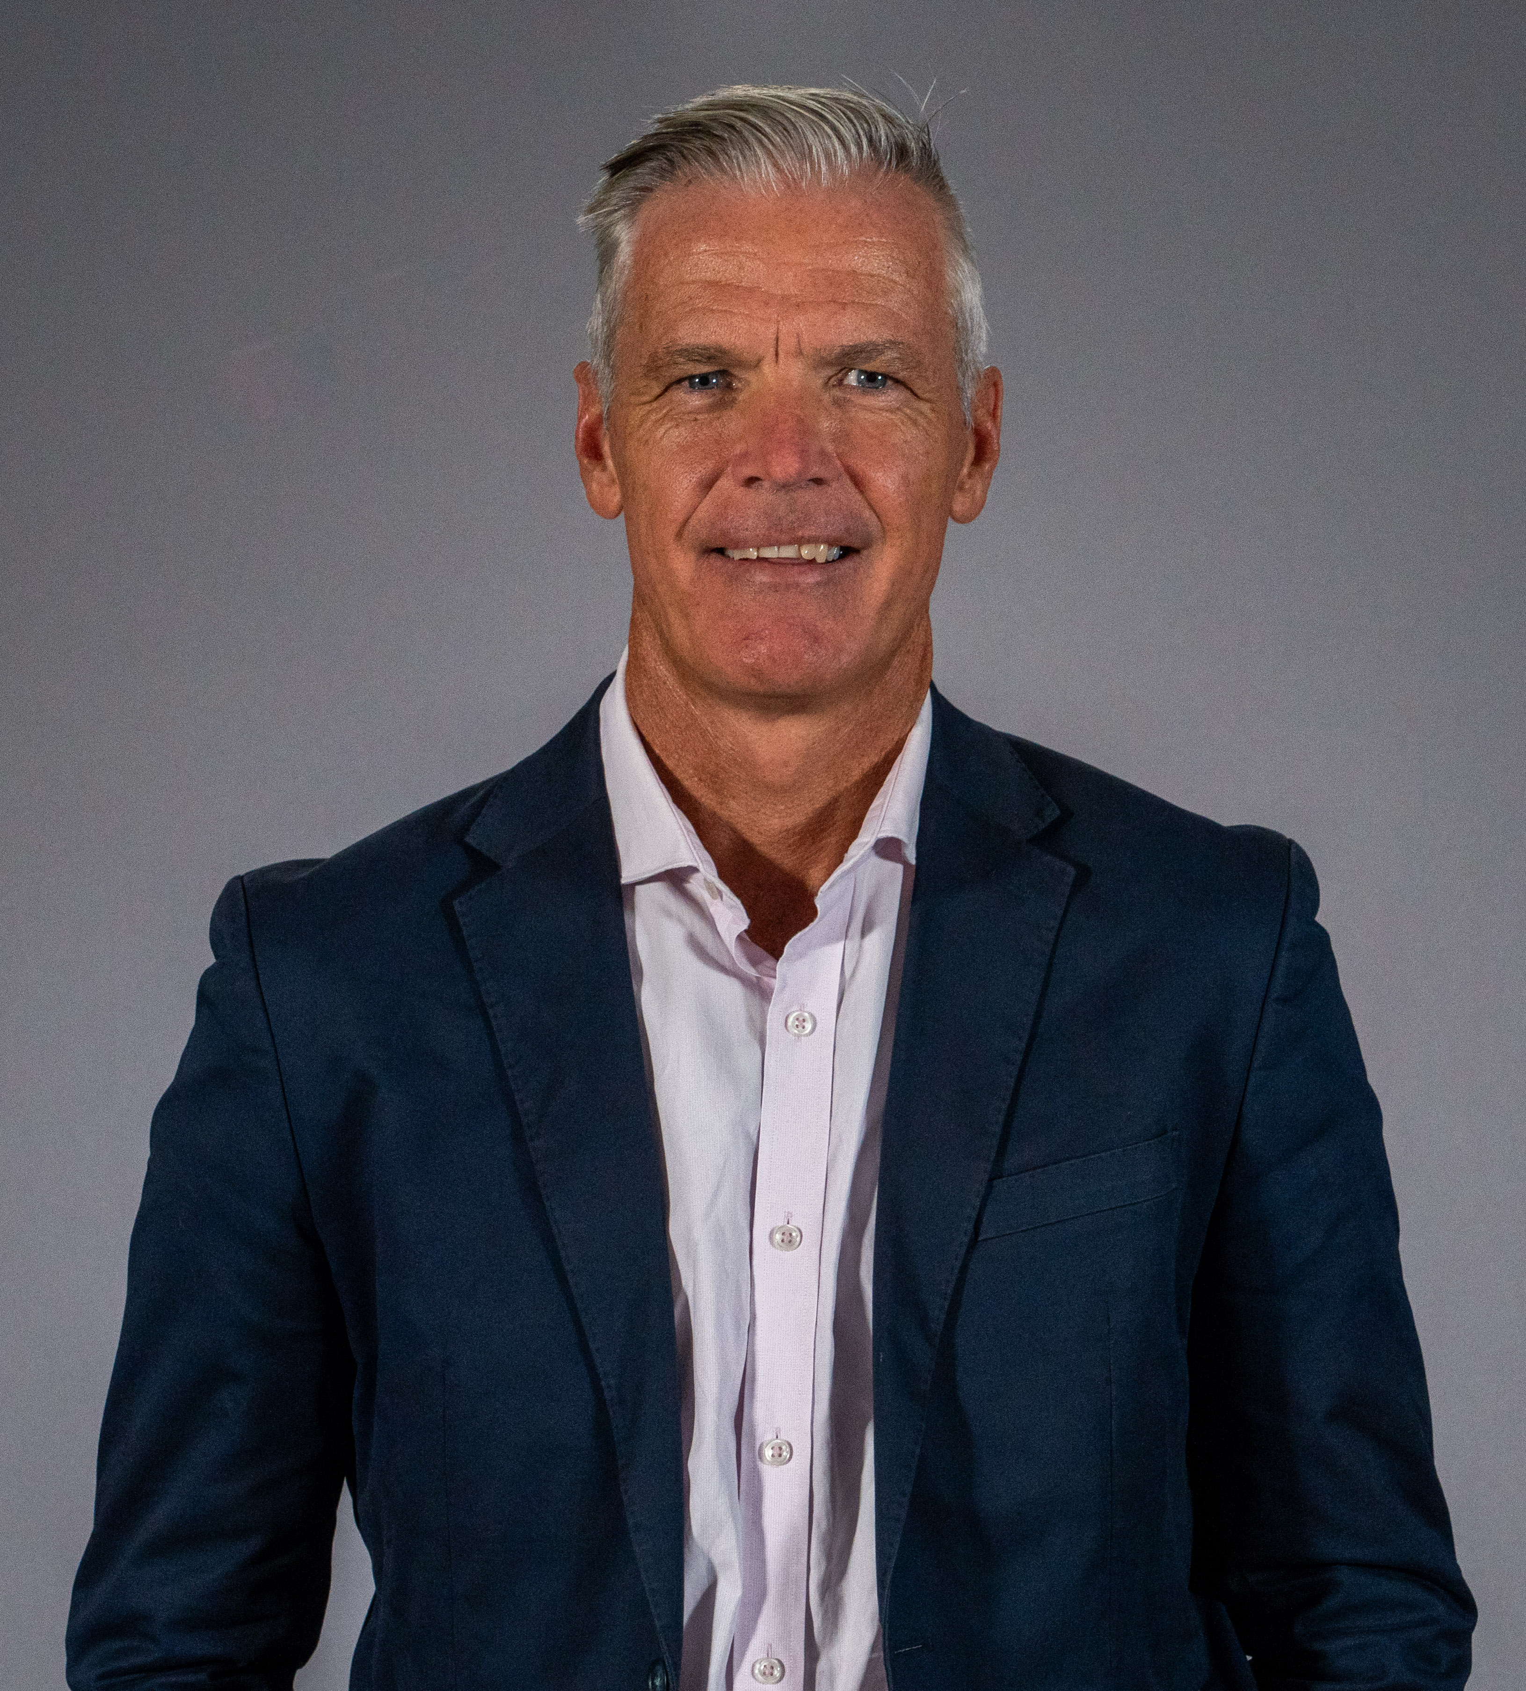
Progress this year on launching – and continuing to refine – a national Developer Rating Scheme (DRS) is very welcome. While it won’t be a silver bullet, the DRS has the potential to be an important step-change in improving accountability on the many good guidance documents, voluntary initiatives, and mandatory requirements that already exist. From my perspective, the outstanding action from the 2023 review we all need to get behind is a more coordinated approach to national communications efforts.
My team is committed to working alongside communities, industry, relevant experts and governments at all levels in the year ahead – and in doing so we will walk the walk on our transparency and best practice expectations by being clear on our own priorities.
We look forward to continuing these efforts, and delivering with other willing partners, in 2026.

Tony Mahar
Australian Energy Infrastructure Commissioner

Community enquiries and complaints
A key role of the AEIC is to help resolve complaints from concerned community members. These can be about proposed or operating wind farm facilities, large-scale solar farms, energy storage facilities and new major transmission projects.
Core principles that guide our handling of complaints:
- We will always act independently, impartially and ethically.
- We use our best efforts to help the parties to find acceptable outcomes and reach agreement on a way forward.
- We will help parties to share facts and evidence-based information relevant to a complaint so they can work towards an outcome.
- We assume the parties involved are genuinely seeking an outcome to the issues raised.
Important boundaries of our work are:
- the Commissioner’s process is a voluntary process
- we cannot stop projects from proceeding or shift projects from one location to another
- we do not duplicate or override the important statutory responsibilities of State and Territory governments or local government authorities. Where appropriate, we will refer complaints to a relevant party or parties and help to ensure that they are addressed.
- We do not make binding directions or decisions.
- We can, however, suggest possible solutions for consideration by the parties.
- We will not provide legal, professional or technical advice.
Anyone can lodge an enquiry or complaint with us – it is not limited to people who will have renewable projects or transmission on their land. In fact, the majority of our cases now come from direct or near neighbours, or local community-based organisations who are concerned.
‘The Bundure District Landholders have found our ongoing communication with the commissioner Tony Mahar of great benefit to us as a group of near neighbours who will be significantly impacted by renewable infrastructure in our landscape. The commissioner has provided us with ongoing support in assisting us in our dealings with key stakeholders.’
– Bundure District Landholders
Most of our cases are about renewable or transmission projects at the proposal stage, prior to approvals being granted. This has been observed over many years. We also get some cases about projects in construction and operation. But there are often well established contact points and alternative resolution pathways by the time such issues arise.
When we receive a complaint, we carefully review the information we have been given. We will make direct contact with the complainant if more information is needed or if we need to talk about our role and what we can do to help. We then work out the best approach to resolving the issues.

This can include:
- providing general information on issues
- putting questions to the proponent in writing for response (a referral)
- contacting government departments to clarify process and procedure questions
- meeting with the parties separately, including sometimes travelling out to site
- convening meetings between the parties to help work through concerns.
Because each case is different, the steps and timeframe to closure vary from days to months. For example, where the concerns are linked to planning and approval processes, it can be many months.

Case information and insights

Case numbers 2025
The calendar year 2025 was our second busiest year in raw numbers, with 205 new cases created. We also re-opened 9 cases. Cases are re-opened when more information or a request is received about the same concerns. Where new concerns or requests are made, a new case is generally opened.
Cases can be:
- a complaint, where someone has specific concerns over a project which they are seeking our help to resolve
- an enquiry, where someone is after more general information or is keeping us informed of an issue they are seeking to resolve with another body (such as a government department or ombudsman).
Of the 205 cases in 2025, 170 of them were categorised as complaints. Sometimes a single contact can contain a little of each, so in general we just report on total case numbers.
Case numbers have continued to generally increase since 2015. A notable peak in 2021 was when transmission was first added to our role.
Figure 1: AEIC case numbers over calendar years 2015 to 2025
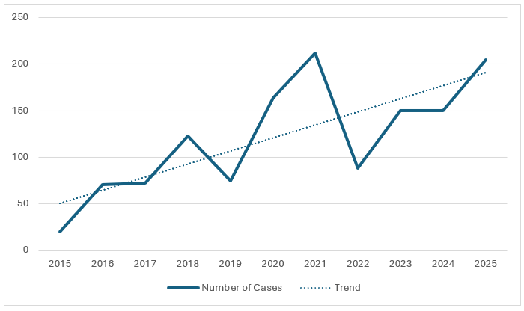

Whilst second highest in case numbers, the variety of different projects raised with us continues to climb. In 2025 we received cases about 78 different projects. As with total case numbers we are seeing a steady increase in the number of projects we have cases for.
Figure 2: Number of discrete projects over years 2015 to 2025
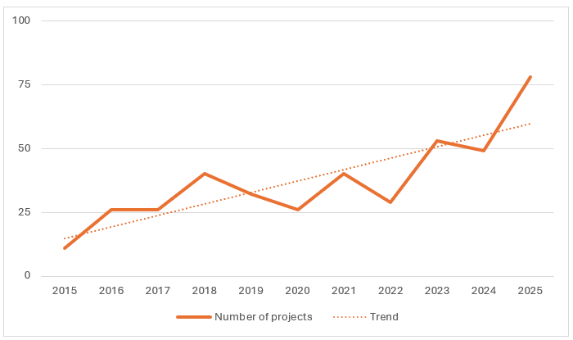
This means that for some projects we received multiple separate complaints. The highest for any specific project was 15 cases, and 17 projects received just a single case.
We do not generally list specific projects and case numbers against them. This is because a complaint in itself is not a finding of any poor behaviour or wrongdoing. Similarly, not having a case does not mean a project is not creating concern in the community or could not improve practices.
For our work, this spread of projects means being across more developer practices and the diversity of different steps, approval processes and timelines and State-based alternative complaint pathways.
For most of these projects we will seek a briefing from the proponent to better understand the scope and history of the proposed infrastructure, and their approach to community engagement. These meetings are captured in our stakeholder engagement activities, which contribute to the relatively high number of formal meetings in the industry category of Figure 5 (see the following section).
The AEIC and the office have a difficult job, and we welcome their efforts and process for managing our complaints. We have provided the AEIC with significant data to substantiate our concerns and the case is ongoing. Tony Mahar and his team have personally followed up with us on several occasions, and they have been very transparent and professional. We commend the AEIC team though for all their efforts to help us navigate the results of extremely poor engagement which is part of their brief and mandate. Thank you to Tony and his team.
- Peter, Community Group Co-ordinator, NSW

Case locations
We found again that most of our case work came from Victoria and NSW – around 90% of our work in 2025. This is fairly consistent with previous years, showing:
- NSW had the highest number of cases in 2025: 49% of cases across 37 different projects
- Victoria was close second highest: 41.5% of cases across 30 different projects
- Queensland: 4% of cases across 4 different projects
- Western Australia: 3% across 2 projects
- South Australia: 1% across 2 projects
- Tasmania: 1.5% across 2 projects
- Northern Territory and the ACT had no cases.

Figure 4: AEIC cases received by jurisdiction
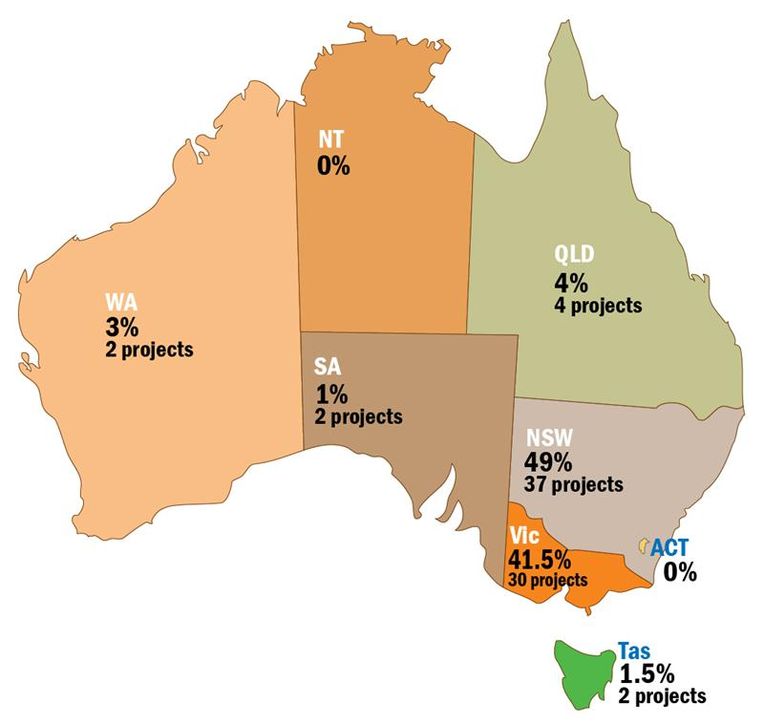
These case locations align with where a lot of the new renewable energy and transmission projects are happening, as well as higher population numbers. But this only partly explains the data.
We have been working to build awareness of our role across the country, particularly in those regions that are seeing a notable increase in transmission and renewable projects. As we continue to better promote our work in other jurisdictions, we expect our case numbers in those areas will increase. For example, in late 2025 we received our first cluster of complaints from Western Australia.
There are also other pathways that people can take for help and support. Various state, industry and peak bodies play different roles. In NSW, for example, the Energy and Water Ombudsman of NSW is currently expanding its role in renewable energy project complaints. In South Australia, the Landholder Information Service can provide support. The AEIC is unique in being dedicated to renewable energy and transmission projects on a national basis.
‘Tony has been of enormous assistance to Origin, helping to navigate a range of challenging community and landholder issues, acting as the honest broker to ensure fair and equitable outcomes. His advice and guidance is often sought and highly valued.’
- Adam Marshall, Group Manager Government, Community & Approvals, Origin Energy

Types of projects – asset types
Wind farms remain the renewable project type that makes up the majority of complaints we receive. In 2025 they accounted for around 50% of cases.
We also had an increase in 2025 in the number of solar farm complaints, with multiple complaints about a couple of projects contributing to this.
At the same time, the proportion of complaints about transmission have decreased. There are increasingly well-established alternative pathways for transmission projects. In our conversations with State-based energy and water ombudsmen, we know their cases are increasing as ours decrease.
The relatively small data set for these means that it is difficult to draw any firm conclusions on a year-to-year basis about any specific asset type.
What it does show is that concerns continue to be raised across all asset types, and our work continues to grow across all the asset types that our terms of reference currently cover. In fact, we have started to receive some contacts about other types of infrastructure such as waste to energy and gas power, and issues around other non-renewables based land uses. These are currently not in our scope, but the issues raised around engagement, process and information are similar.

Figure 4: Complaints by asset type 2015 to 2025
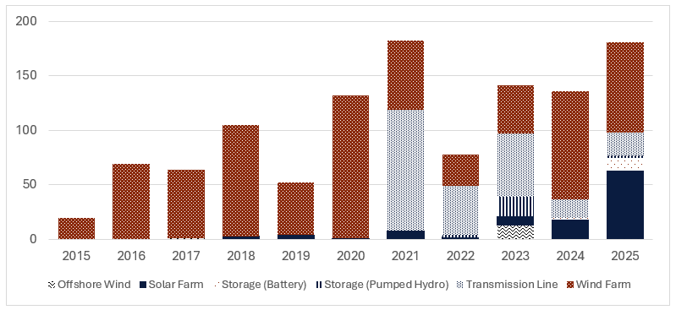

Issues of concern
For each case we open, our team distil the overall concerns raised into specific issues. Each case can have multiple issues identified. We have 19 broad categories which are outlined in detail in Appendix C.
Using these, we can review during a year what are the main issues being raised, to look at how we can encourage more general action as well as targeting specific complaints. We can also look over years to determine any trends.
Because this categorisation is a manual process that does rely on the judgement of team members, we are careful to use this data as an indication only. It also applies to our cases only. We hear a lot through our broader engagement that further informs our understanding of what the biggest issues for community are.
In 2025 the 5 most common issues raised through our cases were:
- community engagement
- planning processes
- amenity
- natural environment
- economic loss.
The main change from last year is that planning processes has significantly increased – more than double on a percentage basis. This has nudged safety out of the top 5, which now comes in at 6th place.
In line with the lower number of transmission-related complaints, issues of land access and route selection have dropped.

Community engagement
Issues around community engagement continue to be frequently raised with us both through cases and in meetings.
Some of the concerns raised include:
Timing of engagement. This is sometimes too late, where people are hearing about proposals via informal ways rather than direct from the company. And too early where not enough information is available
Engagement feeling like a box-ticking exercise. There can be a perception of no genuine listening and active decision-making.
Type of engagement. Many proponents are moving away from ‘town hall’ type meetings. They are finding that smaller group or one-on-one meetings are more productive. There is, however, still some preference for the larger meetings.
Quality of information. People want to be well-informed on how the impacts of a project will be managed. Information can often be too detailed or too simplified to meet community needs.
Not being clear on the nature/degree of consultation being undertaken. Communities need to be aware of the level of influence they can have on a project, and to what extent they can make a difference on specific issues.
Because community engagement can be such a broad spectrum, it is difficult from our current case data to say which specific parts of engagement are the most frequent and therefore should be focused on. To better understand this issue, we will be using more sub-categories for cases this year.
The 2023 Community Engagement Review (completed by the former commissioner) reported renewable developers were exhibiting a lack of integrity in regional communities. This included poor engagement and governance practices and processes which led to a material distrust of the industry.
It also noted that good developers expressed frustration about the negative impact that poor quality community engagement is having on the reputation of the industry, and were advocating for a solution that highlights the good from the bad.
The review recommended that a Developer Rating Scheme (DRS) be developed to provide transparency on a business’s performance, track record and capability, particularly in relation to community engagement.
This DRS has been developed and at the time of writing is in a start-up phase, collating data from companies that will be used to strengthening proponents’ capability in relation to community engagement outcomes. The DRS will not be a silver bullet to completely solve community concerns. However it will be a critical part of the solution once it’s fully operational, providing public tool to give information and confidence on developer performance and capability.
‘When you find yourself a heavily impacted neighbour to a renewable project and there is no relationship with the proponent, it is easy to feel you don't have a voice. It can be very intimidating to stand up for your rights against a global proponent, and I am grateful for the work AEIC does by not only making you feel heard but also in giving you a voice.
I have been working with them for 7 months and found them to be extremely professional and an amazing source of knowledge and information in my quest of working towards a resolution. I can't fault my experience with them. The communication is impeccable and received in a timely manner considering they look after the whole of Australia.’
- Michelle, Renewables project neighbour, Queensland

Planning processes
Planning and other approval processes are critical to renewable projects. These are where the technical assessments of possible impacts, and ways to reduce them, are made. They are also where communities get the chance to make formal submissions or objections directly into the process.
Each state has a different planning and approval framework. These processes can be long and complex. Timeframes can vary greatly and timing of key milestones can be unpredictable.
This has been an increasing issue for some communities. We have seen an increase in people asking for help in understanding planning processes to know when they can have their say.
Frustration at the timeframes is also a common theme. Whilst approval processes may take many years, community may only get a small window to review all the final documents and respond. Community members are often not well resourced and time poor when it comes to providing input into government processes. We have maintained there should be more assistance and resources for councils and community to better engage and understand the planning process with the aim of achieving better outcomes.
Engagement within planning processes also varies a lot. Some departments will only receive submissions via online portals and for limited time. Others will accept via broader methods and at any time up until a decision is made. Feedback on submissions is generally limited to broader assessment reports, not specific details provided. This variation makes it hard for community members to know what process applies in their scenario and how their submissions have been considered. They feel the process is skewed towards approval and that impacts their trust in it.
AEIC has been discussing these observations with planning authorities, and will do further work in 2026 to support a better understanding of planning processes.
‘The team at the AEIC have shown a genuine commitment to ensuring community concerns are properly heard and taken seriously. I am grateful for the way they have worked proactively with proponents and government departments to make sure our voices are part of the conversation. Knowing there is an independent office prepared to listen carefully has made a meaningful difference.’
– Lee, Community Member, Victoria

Natural environment and amenity
While these are different categories, they are often raised together:
Natural environment is about the project's impacts on local flora and fauna, ecosystems, waterways, soil, air quality, and biodiversity
Amenity refers to the pleasantness, attractiveness, and overall enjoyment of a living environment; complaints in this category raise concerns about how a project may negatively affect the comfort and well-being of residents, such as visual disturbances, disruption of tranquillity and changes to the character of the area.
We often hear that communities do not feel regulatory approval processes cover these concerns well enough, or early enough.
Communities report they do not feel their local knowledge is properly sought and considered. Experts or consultants preparing approval documents are usually from outside the area and do not always do on-site visits, and rarely meet directly with community.
Visual impacts are a key concern for many neighbouring landholders but also for broader community groups, First Nations peoples and some local governments. While these are considered in approval and assessment processes, they do rely on a judgement call about how much is too much.
Often communication tries to minimise concerns, and in doing so may give the false impression there will be no impacts at all. When this is not the experience in practice, tension and disappointment arise. Being realistic and clear about actual impacts is important. Tools like augmented reality can help with this.

Economic loss
The category of economic loss encompasses the actual and perceived negative impacts on the financial well-being of landowners, businesses or the community. Concerns may include property devaluation, fears of lost income from tourism or agriculture, uncertainty about increased insurance costs, and effects on local employment.
Many of these are out-of-scope and/or not specific considerations in planning approval processes. They may not be considered in detail, if at all.
There is also a lack of reliable information or evidence on things like the impact of new projects on neighbours’ property values and insurance costs. With many factors impacting these issues, isolating any impacts from a renewable project is difficult. Local real estate agents may propose that a renewable project will decrease property value or make it harder to sell. There is little tested evidence of this, however, and more evidence and research needs to be conducted.
Another concern has been the taxation treatment of various payments. This requires a considered and nationally consistent approach. Work to resolve this issue nationally is being prosecuted by AEIC through ECMC.

Other complaint issues and themes
Some other themes we are seeing are:
- low numbers of complaints about offshore wind, consistent with the slower progress of these proposals
- new cases for transmission proposals are low, but we recognise ongoing strong opposition in certain stretches of some routes. We continue to hear concerns through engagements and meetings, but not as much through specific cases
- bushfire risk remaining an ongoing concern. Many people in rural and regional areas have had first-hand experience with wildfire impacting their land. Many are members of fire agencies and have spent time at the frontline. Proponents need to invest time and effort into the detail of how they are managing this risk, providing access to experts and answering location-specific concerns
- early assets now reaching end of life, with decommissioning a concern for communities. Clarity on roles and responsibilities, including costs, disposal options and recycling, continue to be raised. See further information in the next section about AEIC’s work on this.
‘I'll shout praise to the Commissioner, as AEIC has been the only Federal & State Government Office that has replied to any of our correspondence and had the courage to meet with myself and my neighbour via Microsoft teams."
– Karen, Community Member, NSW

Alongside assisting people with individual complaints and enquires, in 2025 we also focused on improving our policies, processes and practices. As our case numbers increased, we found some challenges in keeping up. We found ways to streamline our work, while aiming to give a more consistently high level of customer service. This is continuing into 2026.

Stakeholder engagement
Meeting with stakeholders is critical to our work in helping to make the energy shift smoother and fairer.
‘The AEIC puts regional communities at the centre of its work, with the Commissioner spending real time on the ground listening directly to local concerns. That accountability is important – it strengthens projects, lifts industry standards and builds trust where it matters most.’
– Rob Wheals, CEO, Squadron Energy

In 2025, we spent time in every State and Territory (Tasmania visited in February 2026). In total, we were on the road in the community close to every second week, meeting in-person with community members and industry and government stakeholders.
The Commissioner participated in more than 440 discrete external engagements in 2025, often with other AEIC team members. We also took every opportunity to have informal conversations with community, industry, government and other subject-matter experts.
Figure 5: Breakdown of Commissioner’s formal external engagements by stakeholder cohorts
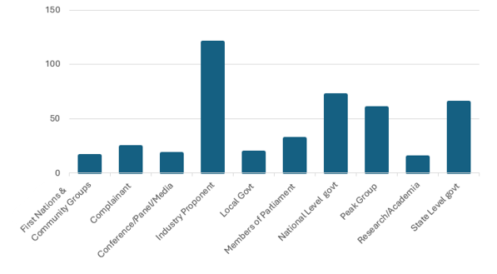
There is an important circular flow to our engagement work. We listen and learn about their perspectives and experiences, successes and challenges. We provide advice and share examples that might support better outcomes. And we take the good examples from these engagements to share elsewhere.
Because we work directly with community members through our cases and through travel and forums, we are able to bring their views into forums such as the Rewiring the Nation Advisory Committee. We can represent the community voice where they are not always directly present.
There are many organisations in the energy ecosystem – government, peak groups, industry and community. It can be complex to piece together and understand clear roles and responsibilities and who to talk to. We have built strong connections across jurisdictions and sectors, and we can use these relationships to help community members find the right path.
As part of our role as an independent and trusted source of credible information, we aim to be clear and transparent about how we fit in this system, so that we can more effectively help community members to understand and navigate it. We made the step forward on this in 2025, through a memorandum of understanding with the Energy and Water Ombudsman NSW. We intend to pursue more formal partnerships like this, and use relevant publications, to further promote systemic clarity in 2026.

Parliamentary platforms
Our Annual Report to the Australian Parliament was tabled on 23 July 2025. Publishing the annual report meets transparency and accountability obligations for the role of Australian Energy Infrastructure Commissioner. It is also part of our how we share with communities and stakeholders. It outlines what we are seeing and hearing in the transition, and what we are doing to support a smoother and fairer experience.
In 2025, the annual report was promoted via a media release and an accompanying opinion article by the Commissioner. We also held briefings with various State and Territory energy and planning ministers.
The Commissioner appeared 3 times before parliamentary committees in 2025:
Senate Standing Committee on Environment and Communications
- Additional budget estimates (2024–25) on 24 February
– Along with an update on the office’s ongoing work, the Commissioner’s Opening Statement also outlined his motivation for taking on this public role, his passion for rural and regional communities, and his principled approach to relationships and balance.
- Supplementary estimates (2025-26) on 1 December
– A key theme in the Commissioner’s opening statement was the need to improve clarity and accountability on issues being raised by the community, acknowledging that the energy transition is large, long-term and involves both disruption and opportunities.

- Questions on notice from these hearings are available online from the Australian Parliament’s Senate Estimates webpage. Questions were broadly about our complaint case work, stakeholder meetings and budget.
Senate Select Committee on Information Integrity on Climate Change and Energy
- The Commissioner appeared at the public hearing for this enquiry on 29 September, following a written submission to the enquiry. More information can be found in the Hansard transcript and inquiry submission.
Our submission to the Information Integrity inquiry (also known as the ‘mis/dis information inquiry’) highlighted how genuine questions, inherent uncertainties and safety concerns across the life-cycle of a new project can be fuelled by misinformation.
Given pre-existing and broader issues with the levels of distrust towards public institutions and developers, we endorsed a more pre-emptive approach to ensure individuals are accurately and meaningfully informed.
Effectively communicating the ‘what’, ‘why’ and ‘how’ of the energy transition in a way that is transparent, clear, and accessible will be an integral aspect of ensuring ongoing social licence. The timely updating of existing evidence-based information on long-standing issues (such as windfarm noise) is also important.

Media
Media platforms are an important way that we share information about our work and contribute to discussions. We have used opinion articles, podcast and radio interviews to provide our independent and balanced perspective on the energy shift.
Some of the key media examples are:
- ‘Renewables developers must work with communities if they want social licence’ in The Australian, 2 January 2025
- ‘We must get this right’ opinion article printed in The Weekly Times on 19 February 2025
- ‘”Green Cowboys” hit energy rollout’ in The Australian, 18 March 2025
- ‘A Fair, Coordinated, and Community-First Transition’ emPOWER podcast interview, 3 June 2025
- ‘’Show your face’: Energy infrastructure czar tells renewable project bosses to front up to communities’ in Renew Economy, 21 July 2025
- ‘The power imbalance is being exploited and the benefits aren't being shared well enough’ in Energy News Bulletin, 11 September 2025
- ‘Farmers in the dark on wind farm clean-up costs’ in The Financial Review, 29 October 2025.

There have been more radio interviews during regional travel, some of which were then syndicated in other regions’ news bulletins.
In 2026, we are continuing to work with various media channels to provide a platform for concerns and issues to be raised and addressed. We will also explore opportunities for use of social media and newsletter communications.

Conferences and forums
The Commissioner is regularly invited to address a wide range of energy sector and regional forums.
Through these forums we can amplify key messages about what we hear from community, what we think needs to be addressed by the private and public sectors, and what role the AEIC plays in supporting the change that is needed.

Table 1: Conferences attended by Commissioner in 2025
Date | Event and location  * Commissioner gave a keynote/presentation or participated in a panel
18 February | NSW Farmers Energy Transition Taskforce, Dubbo
*14 March | Global Food Forum, Melbourne
*6 May | Clean Energy Council Australian Wind Industry, Melbourne – speech
*21 May | 5th Annual Australian Renewable Energy Zones Conference, Sydney  Keynote – Facilitating leading practice in the renewable infrastructure transition:​ Observations and challenges ​for Renewable Energy Zones​
30 May | QREC Community Renewable Energy Forum, Hughenden
*17 July | Australian Wind Energy Conference, Melbourne  Panel – Rating Australia's Wind Energy Market – Can Australia Transition from a Global Follower to a Leader?
23 July | National Renewables in Agriculture Conference, Bendigo
*1–2 September | FCA Farming Forever National Summit, Canberra  Keynote – Community Benefit Sharing and Local Support for Large Scale Renewables
*11 September | WA Energy Week, Perth  Keynote – Geo-politics v. local realities: helping Australians navigate the energy shift
*22 October | Energy Charter Landholder and Community Engagement Training, Dubbo
*5 November | RDA National Forum, Canberra

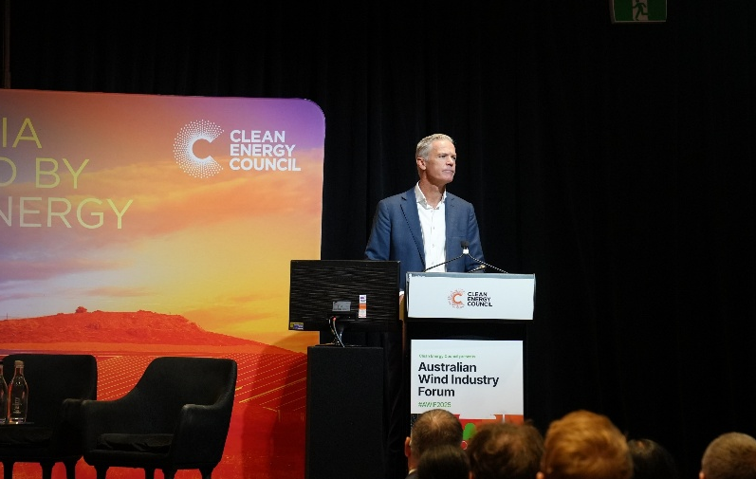
Tony Mahar addressing the CEC’s Australian Wind Industry Forum (6 May)

Site visits, community meetings and targeted events
Alongside these public events, the Commissioner and/or the AEIC team have also addressed multiple industry, government and community meetings. These range from strategic planning days and training sessions for government agencies, to community information sessions, collaboration workshops and local government and energy industry capability-building events.
These smaller gatherings are an equally important part of our ongoing stakeholder engagement, as they are often where we hear from local community members about their personal experiences. Some are optimistic about the potential wider benefits of a new project, while others are concerned about heightened tensions in their region.
As a result of the meetings with individuals and community members raising their concerns and questions, the AEIC has developed a work plan to seek to address the lack of clarity on a number of issues. The issues include:
- public liability insurance
- fire risk
- land valuation
- decommissioning or end-of-life management for the assets
- noise and shadow flicker
- contamination risks from infrastructure.
It is the intent of the AEIC to work with stakeholders to provide up-to-date information relating to the facts on these issues. Where possible, the AEIC is also working towards measures that address the concerns of communities, and changes to policies.
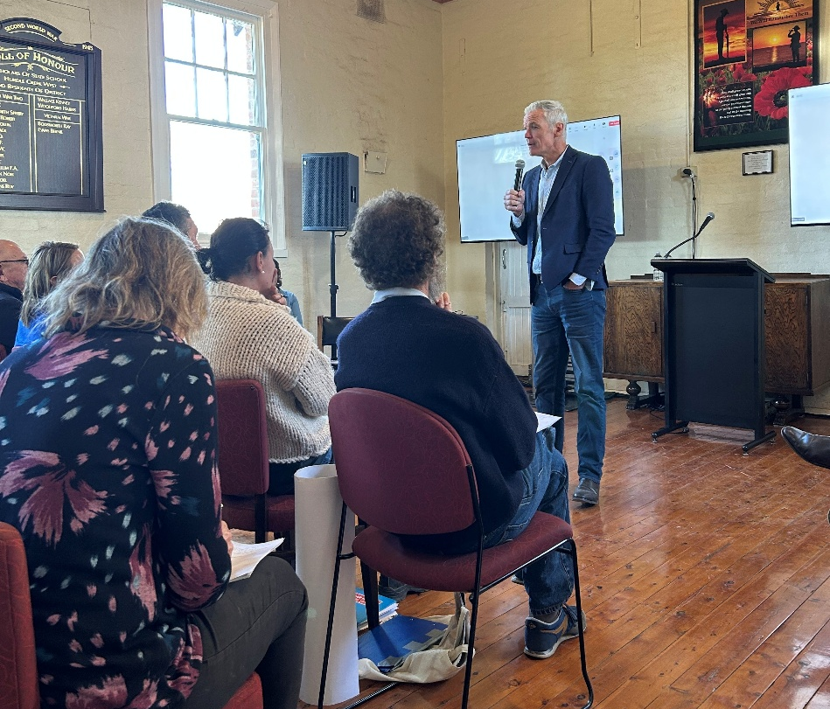
Tony Mahar meeting with local residents about a proposed generation project

One of the Commissioner’s key challenges to the energy sector has been to send senior executives to proposed project sites and speak directly with local residents. This simple act of listening and practical engagement can help to improve (and/or reset) relationships and ground-truth project realities. On one occasion, the Commissioner accompanied the CEO of a project proponent on their visit to a host community, helping to facilitate a robust but respectful conversation.
Another significant event was joining the federal Climate Change and Energy Minister Chris Bowen on a tour to the NSW Riverina region in December 2025. During the visit, we met with farmers, community members and the council to get an insight into the concerns and opportunities in the region, and ways of addressing them. The trip was an invaluable opportunity to provide both the Minister and the community with an up-to-date perspective on the impacts the energy shift can have.
These visits were valuable and worthwhile on all fronts. We acknowledge the Minister and senior executives for having a real presence in the regions. We are also grateful to those local community members who give up their time to meet.
‘The AEIC and Federal Commissioner Tony Mahar have been very helpful to our local community situated between Hay and Deniliquin in south western NSW throughout 2025. Tony very quickly met landholders locally and listened to those concerns and acted accordingly. He followed up online with further actions and returned to the district bringing the Federal Energy Minister later in the year. This support has given landholders hope that their concerns are being taken seriously at the highest levels."
– Duncan, Farmer and landholder, Riverina, NSW

First Nations engagement
The updated terms of reference now includes a specific reference to our role in promoting the information and engagement needs of First Nations communities (see Appendix A).
As with other areas of energy shift, there is a lot of work already underway at Commonwealth, state/territory and project level. In 2025, we focused on establishing key connections, understanding existing work and exploring where the AEIC can best contribute and support without duplication and within our resource capacity.
We have engaged in development of the First Nations Clean Energy Strategy, which is co-sponsored by the Minister for Energy and Climate Change and the Minister for Indigenous Australians. Through the strategy’s progress reports, we have identified specific actions where we could play a support role. We have held meetings with First Nations groups to establish critical relationships and have attended launch events at invitation from organisers including the First Nations Clean Energy Network.
All AEIC team members are increasing cultural competency through formal training. In July, the AEIC team participated in an On Country cultural session with Wadawurrung Traditional Owners Aboriginal Corporation.
It was great for the AEIC team to be able to meet with Wadawurrung representatives out on Country. We appreciated the chance to hear some open and honest sharing of some first-hand experience of the energy shift. It gave the team a lot to think about as we travelled through the area visiting sites. We heard perspectives on the intersect of renewables with culture and Country, in an area that has already seen a lot of renewable developments and has more to come. Thinking about impacts and opportunities from a different perspective is important for our work and how we can encourage proponents to do more and better.
– Carolyn Francis, Assistant Commissioner AEIC

In December, the Commissioner met with the DCCEEW First Nations Clean Energy and Environment Advisory Committee to share updates on our work and observations. The committee assists the department and Minister to identify opportunities for First Nations to benefit from the net zero transition, including through economic participation and community-led projects. The Commissioner will return to this forum during 2026.
We will continue to work alongside these existing frameworks and committees through 2026, building relationships and promoting our role in assisting First Nations people with enquiries and complaints about specific projects.

Information availability and best practice
The Commissioner’s terms of reference include a clear mandate to lead efforts to promote best practices, information availability, and provide a central, trusted source of credible information.
As with our project-level case resolution efforts, this collaborative role does not mean we are a ‘white knight’ – or the single source of truth – on every point of contention or disagreement in Australia’s energy shift.
Instead, we approach this work with humility and respect for others’ experience and expertise. We expect industry and governments to be proactive in providing basic project process and planning information – and we acknowledge where good community engagement and local benefits are being secured. Our working assumption is that shared facts are the basis for constructive dialogue, systemic improvements and better outcomes.
In helping to make the energy shift smoother and fairer through these efforts, we know there are many variables and uncertainties in the transition. We wouldn’t be adding value for anyone if all we did was provide another list of those challenges.
Whether it is on a long-standing systemic issue (like decommissioning), or encouraging efforts across jurisdictions (like progress on the Community Engagement Review), we are committed to harnessing the best available evidence and providing our independent and balanced view on what is working well – and calling-out where more effort is required, and by who.
‘In 2025, our collaboration with the AEIC continued to demonstrate what is possible when communities, industry and government work together with shared purpose. From supporting the National Landholder + Community Engagement Training in Dubbo, to engaging with the Landholder Lived Experience Panel for the Developer Rating Scheme and attending the Regional Energy Accord Roundtables, our joint focus has been on lifting practice, strengthening trust and ensuring regional voices genuinely shape the energy transition.
We value the AEIC’s partnership and remain committed to driving practical, people-centred outcomes for landholders and communities across Australia.’
– Sabiene Heindl, The Energy Charter CEO

The national stakeholder landscape is as complicated as the energy system itself. There are multiple initiatives and models being discussed to help local communities better navigate the challenges and opportunities, whether through individual local leadership training or models for improving cross-sector coordination, regional planning and community benefits.
Promoting these best practice examples is an important first step (see, for example, the Regional Renewables “Community Showcase” website). As highlighted by theme six (recommendations 8 and 9) of the Community Engagement Review, however, there is more work for governments to do if we are to proactively support and empower regional Australia during the energy shift.

Website and AEIC publications
Our website www.aeic.gov.au is our main conduit for sharing direct information, with links to a range of trusted sources.
In 2025, we made rolling updates to improve the website. We made it more clear and easier to find things, and have added copies of our submissions and some speeches. We have further updates to the site’s structure coming in 2026, as well as more links to new information from other sources.
We have also re-located on our website the previous Commissioner’s 2023 ‘Observations and Recommendations’. While this point-in-time summary of key issues and opportunities remains a useful shared reference point, we have decided to change our approach to providing updates and our views on specific issues and challenges.
We will more proactively publish information on discrete topics throughout the year, rather than primarily in the annual report. This will allow us to be timely and responsive to changing needs and to quickly get the information where it needs to be.
In general, these will take the form of:
- fact sheets that are short documents, written for a public audience, to provide reliable and consumable information on topics that are frequently raised with us
- position statements that present the Commissioner’s opinion or recommendations.
In 2025, we published:
- Position statement: Treatment of Renewable Energy Assets at End of Life – Protection for Landholders (27 October)
- Position statement: Public Liability Insurance for Landholders Neighbouring Energy Infrastructure (4 December)
- AEIC team: About Us flyer (revised) – available on request
- AEIC team: Our role in planning and approval processes – available on request.
In addition to formal submissions and direct engagement with policymakers, regulators and industry, we can also take an active role in crystallising issues and levering opportunities. These might otherwise be put in the ‘too hard basket’.
Our work in 2025 on decommissioning and public liability insurance are clear examples of how the AEIC’s unique role can help make real progress on long-standing issues.
Uncertainty and concerns about these issues have been raised by local community members for many years. They have also regularly been picked up in media reports. As a result, trust in the energy shift has been hamstrung by a lack of confidence in prevailing rules and requirements and by misinformation. Responses to community concerns – like ‘probably not’, ‘it depends’ and ‘we haven’t seen any evidence of that’ – aren’t good enough.
To build consensus and momentum on these issues, we have consulted with a range of organisations in developing our position statements.
In the case of landholder concerns with the potential public liability insurance implications of neighbouring renewable energy facilities, the Commissioner held a roundtable to bring together the renewable energy industry, the insurance sector and farming groups.
The ‘convening power’ of the AEIC enabled a genuinely collaborative and solutions-focused discussion. Through this process, a strong consensus emerged on the shared goals of delivering confidence for landholders, predictability for developers and operators, and clarity for governments and insurers.
Work continues in 2026 to develop and embed a nationally consistent approach to ensuring neighbours do not face any increased insurance liability or costs for their public liability insurance.
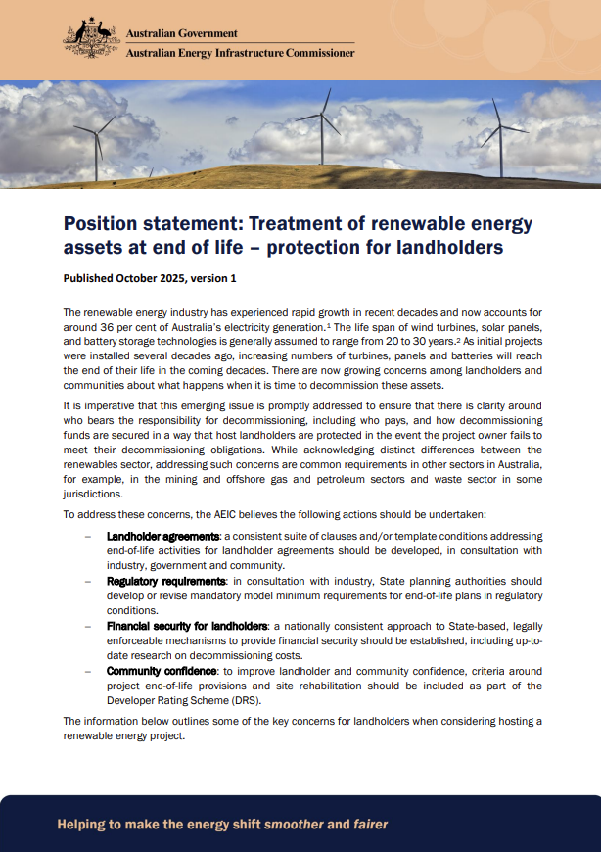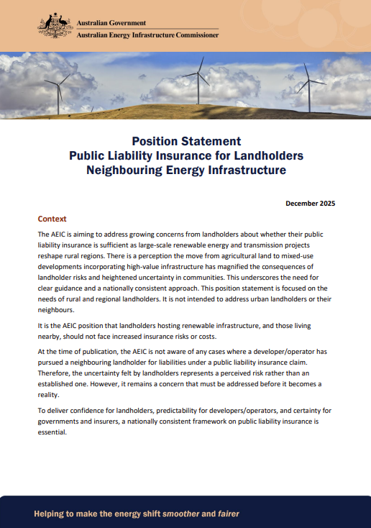

Submissions and consultations
There are many inquiries and reviews that intersect with the energy shift and the Commissioner’s role. Making submissions to these allows us to represent community concerns and themes in a way that may be difficult for community to do themselves.
In 2025, we made 11 formal submissions to policy and regulatory processes. Some of these submissions were taken as written, others prompted follow-up meetings and/or the Commissioner’s participation in a parliamentary hearing. Such submissions are generally published, either on the relevant government website or our own (www.aeic.gov.au).
Table 2: AEIC formal submissions in 2025

Sub Date | Process | Scope | AEIC key points
10 March | NSW Transmission Planning Review: Consultation Paper | Consultation paper seeking stakeholder input on draft assessment criteria for the Review, which considers transmission planning arrangements in NSW. | Importance of effectively informing and involving local communities in route selection decisions; managing construction impacts; maximising regional benefits; and clarifying governance roles and responsibilities.
Sub Date | Process | Scope | AEIC key points
19 May | NSW Transmission Planning Review – Options Paper | Options paper outlining the review’s assessment framework and problem definition to consider transmission planning arrangements in NSW. | Governance options to improve community engagement and enhance transparency.
3 June | A Fresh Start for Queensland: Communities empowered on renewables | Proposed amendments to the Queensland planning framework introducing a new community benefit system, including social impact assessments and community benefit agreements . | Community engagement and the framework for the social impact assessment.
6 June | Productivity Commission’s ‘5 Pillars’ inquiry: Investing in cheaper, cleaner energy and the net zero transformation | Inquiry into priority reforms and potential recommendations to speed-up approvals for new energy infrastructure. | Delays in planning approvals processes for large-scale renewable energy projects; any reforms should help build local community confidence and support for new energy infrastructure
10 June | Victorian Energy Safety Review – Consultation Paper. | Review aims to identify safety risks, effectiveness of existing regulatory frameworks, and proposed reforms as the energy system incorporates more renewables/storage technologies, and becomes more dispersed. | AEIC’s experience with community safety concerns and incidents, and briefly discusses options for reform as outlined in the consultation paper.
24 June | Draft 2025 Victorian Transmission Plan | Introduces a new approach to planning for renewable energy and transmission infrastructure. | The importance of transparent information and recognising cumulative impacts; clarity of land requirements and plan implementation.
25 July | NSW Transmission Planning Review – Interim Report | Interim report sets out draft recommendations for transmission planning arrangements in NSW for stakeholder feedback. | Clarification of governance roles, coordination and timeliness of NSW transmission planning; enhancing community engagement and transparency.
Sub Date | Process | Scope | AEIC key points
18 August | WA Draft Guideline on Community Benefits for Renewable Energy Projects – Consultation Paper | WA’s draft benefit sharing guidelines aim to provide information to communities and industry about benefit sharing arrangements and improve confidence and clarity. | The importance of community benefits; possibilities for aggregated benefit sharing; benefit sharing arrangements for First Nations people; and benefit sharing arrangements for transmission infrastructure.
10 September | Select Committee on Information Integrity on Climate Change and Energy | Examines the prevalence and impacts of misinformation and disinformation relating to climate change and energy. | AEIC’s role in the energy shift; the need for accurate, trusted and reliable information; the importance of Recommendation 6 of the Community Engagement Review; and the role of different levels of government.
15 September | PC ‘5 Pillars Inquiry’: Investing in cheaper, cleaner energy and the net zero transformation – Interim report | Potential priority reforms and recommendations to speed-up approvals for new energy infrastructure. | Enabling holistic and effective regional planning; improving community consultation and social licence; importance of practical information-sharing.
5 November | Victorian Access Regime and Community Engagement and Social Value (CESV) Guidelines | Victorian Government setting new rules to manage how renewable energy projects gain access to the state’s transmission network. | Creating economic benefits and social value; important requirements for project developers; suggestions on guidance on the valuation of economic and social benefits; formalising benefits; assessing projects against expectations and outcomes; proposed network access arrangements.

We also provided informal direct feedback and best practice advice to government agencies and industry proponents. Examples of this include:
- the First Nations Clean Energy Strategy Progress Update
- officer-level and intergovernmental resources on social licence considerations
- multiple projects landholder and community engagement strategies
- the context, scope and potential directions for intergovernmental collaboration on issues like the taxation status of landholder payments, and decommissioning arrangements
We have also been consistently contributing via the Stakeholder Reference Group (and individual engagements) on the National Developer Rating Scheme. The launch of this tool in 2026 will be another important milestone – again, not a silver bullet in itself, but potentially an important shared reference point on expectations and performance.
We are realistic that the detailed methodology won’t be perfect on Day 1 or shift the dial across the energy sector overnight. We do, however, remain optimistic that as we will continue to work with DCCEEW, Equifax and industry, a ‘get started, get better’ approach to this tool can help deliver the better outcomes we all want to see.

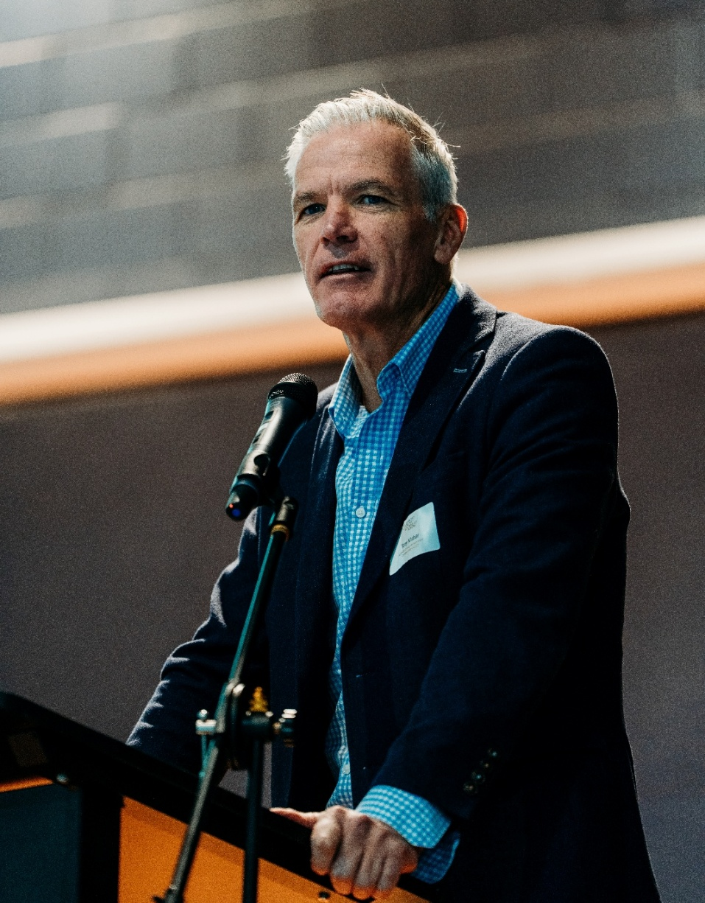
Commissioner Tony Mahar speaking at a community forum

Community Engagement Review (2023)
At the time of writing, it is over 2 years since the previous Commissioner Andrew Dyer delivered the Community Engagement Review report to the Australian Government.
Since then, the Energy and Climate Change Ministerial Council (ECMC) – which includes the relevant portfolio ministers from the Commonwealth (Minister Bowen) and all States and Territories – has discussed the 6 themes and 9 recommendations of the report on multiple occasions. Ministers have agreed in full or in-principle to the report’s recommendations and published on 19 July 2024 a schedule of activities to provide further details on all jurisdictions’ related works in progress. A summary of the recommendations and link to further documents is in Appendix D.
Our terms of reference include that the Commissioner will assist the Australian Government on the implementation of the review, consistent with any advice made by ECMC. From our perspective, the findings and recommendations from the 2023 Community Engagement Review represent a key milestone during Australia’s ongoing energy shift, and a clear roadmap for the specific improvements and shared directions needed from developers and governments.
Responsibility for tracking and reporting on ECMC’s implementation of activities lies with ECMC itself. But delivery of related activities is not directly the same as having an impact, and there may be some time before the actions truly pay off for communities. There needs to be an ongoing commitment to ensuring clear outcomes are achieved and measured from the work going on by various parties.
We have embraced – and welcome accountability for – our unique role in ensuring the findings, themes and recommendations of the review will not be left unattended. In 2025, that work included the Commissioner writing to all state and territory energy ministers to emphasise our ongoing commitment to the review recommendations, to seek progress updates and to offer AEIC support where needed. We met individually and collectively with ECMC members to better understand their jurisdictions’ perspectives and progress. We will continue this in 2026 through new and existing forums
As mentioned in the above section, we have been active in support of the Developer Rating Scheme, Recommendation 1 of the review, and in shaping its development.
When we are regularly asked how the recommendations are going – or what our ‘scorecard’ on implementation progress is – our answer is 2-fold. Simply put, there are lots of good things happening across the developer conduct, project and site selection, regional and system planning, and community benefit spectrum. At the same time, however, with the increased activity in the regions, the number of projects seeking approval, and the rise of opposition disinformation, there is no doubt there remains lots still to do, and we are a long way from ‘mission accomplished’.
In summary, the sustained improvements envisaged by the previous Commissioner’s report – and to which all governments have committed – require a further commitment of resources and a holistic and coordinated effort between industry and government. We will continue to fulfil our role as a champion for the shared aims of the 2023 report.

Operational and strategic priorities in 2026
The decision to publish our operational and strategic priorities in 2026 is part of our intentional approach to ‘walking the walk’ on how we play our role in helping to make the energy shift smoother and fairer.
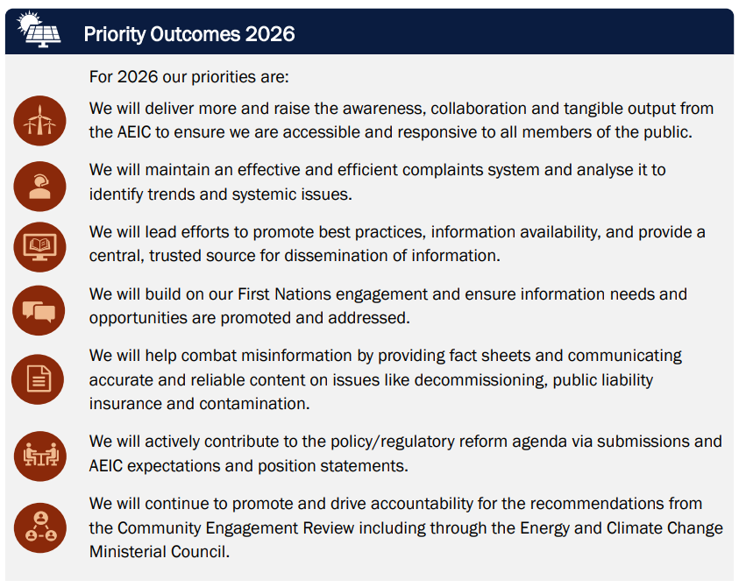
Whether it is over a kitchen table with a concerned resident, or at a formal meeting with senior government officials or industry executives, we are committed to respecting the time, lived experiences and integrity of those we work with. In practice, that means making the most of all these conversations and collaborations by preparing appropriately, listening with curiosity, and acting with clarity and shared purpose.
To support our core case resolution, targeted information availability and best practice objectives, in 2026 we will be putting particular emphasis on:
- fostering strong relationships and engaging across broad stakeholder groups
- continuing to use conferences, events and media to promote our work, share information, and encourage better practices
- publishing topic-specific factsheets and position statements to promote credible information and articulate our observations and recommendations.
Building on our year of listening and learning in 2025 regarding the Commissioner’s new role in ensuring First Nations engagement is promoted and addressed, we also look forward taking our next steps with this work in 2026.
As ECMC seeks to move from an initial implementation phase on the Community Engagement Review to more of an ongoing continuous improvement perspective, we will continue to encourage more active coordination and (where possible) national consistency. We will lean-in on helping governments to stay the course on the commitments contained in the review.
The absence of accountability and clear identification of outcomes against the review recommendations risks undermining the role of ECMC and the office of the AEIC. More broadly, the acknowledgment of the importance of social licence and community concerns risks being ignored to the detriment of the energy shift.
A particular focus for us in this regard is Recommendation 6 and the need for a more structured and comprehensive approach to a national communications program on the energy shift.
Fundamentally, this recommendation is not about ‘another advertising campaign’, but requires a collective and contextualised effort to explain the pragmatic reasons for the energy shift and empower affected residents and local communities with the resources they need to navigate it.

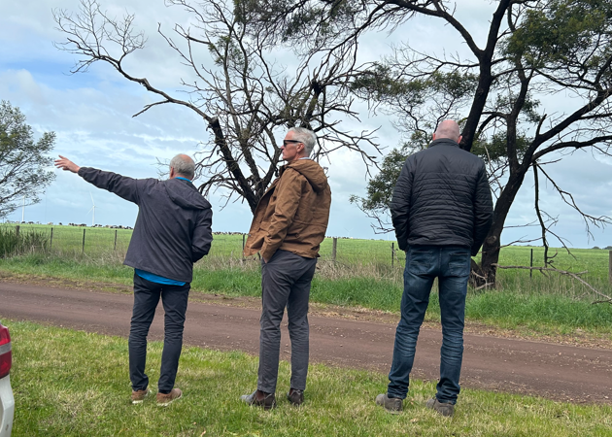
Visiting a rural community with landholders and local government

Appendices

Appendix A: AEIC terms of reference (2024–27)
The role of the Australian Energy Infrastructure Commissioner was announced by the Australian Government on 26 March 2021, expanding and replacing the role of the existing National Wind Farm Commissioner.
The Commissioner will work collaboratively with all levels of government, scientists, experts, industry and the community to resolve complaints from community members about proposed and operational wind farms, large-scale solar farms (5 MW or more), energy storage facilities, such as pumped hydro and large-scale batteries (1 MW or more), and new major transmission projects.
The Commissioner will refer complaints about wind farms, large-scale solar farms, storage facilities and new major transmission projects to the relevant respondent or authority, and help ensure they are properly addressed.
The Commissioner will lead efforts to promote best practices, information availability, and provide a central, trusted source for dissemination of information. The Commissioner will ensure First Nations engagement and information needs are promoted and addressed.
The Commissioner will assist the Australian Government to implement the recommendations of the AEIC Community Engagement Review, in line with any advice in relation to those recommendations made by the Energy and Climate Change Ministerial Council.
In fulfilling these duties, the Commissioner will apply balance to the interests of the energy and agricultural, regional and rural sectors and other stakeholders impacted by the renewable energy transformation.
The Commissioner, supported by the Australian Government Department of Climate Change, Energy, the Environment and Water, will report to the Minister for Climate Change and Energy and provide an Annual Report to the Australian Parliament on delivering against these terms of reference. The Commissioner may also, by agreement with the Minister, lead reviews relevant to the Commissioner's role and expertise.
The Commissioner’s role will not duplicate or override the important statutory responsibilities of other jurisdictions, such as those relating to the planning and approval of wind farms, large-scale solar farms, storage facilities and new major transmission projects.

The AEIC terms of reference were updated on the appointment of Tony Mahar, effective 19 December 2024.

Appendix B: Office history and current operational arrangements

Brief history of the AEIC
The Australian Energy Infrastructure Commissioner is an independent non-statutory ministerial appointment originally established in October 2015 by the Australian Government. The role at that time was known as the National Wind Farm Commissioner and was initiated by Recommendation 5 of the 2015 Senate Committee on Wind Turbines Interim Report.
In November 2015, Andrew Dyer commenced his appointment to the role for an initial 3-year term. Following an independent review of the role by the Climate Change Authority in October 2018, the role was renewed for a further 3 years and expanded to include large-scale solar farms and energy storage facilities.
In March 2021, the Australian Government announced a further expansion to the role, to include new large-scale transmission projects. At this time, the role was renamed to the Australian Energy Infrastructure Commissioner.
Andrew Dyer announced his retirement in March 2024 after 9 years in the role. An interim Commissioner, John Sheldon, was subsequently appointed from within the Department of Climate Change, Energy, the Environment and Water (DCCEEW). On 23 September, the appointment of Mr Tony Mahar as the new ongoing Commissioner was publicly announced, and Tony commenced on 19 December 2024.
The Commissioner’s scope is set through terms of reference. These are available at Appendix A and on our website.

Current staffing and resources
The Commissioner is supported by a team of 7 staff.
As part of the Australian Government’s response to the Community Engagement Review (2023), following the 2024–25 Commonwealth Budget the team includes:
Assistant Commissioner – works with and on behalf of the Commissioner. Provides strategic leadership on workplan and stakeholder engagement (including First Nations), complaints oversight/support and departmental liaison.
Executive Officer – supports the Commissioner and the team by providing strategic advice and operational leadership, including project-specific capacity and delivery oversight, and internal coordination, resources, capability-building and governance needs.
Executive Assistant – manages the Commissioner’s diary, travel, correspondence and administrative support.
Case Handling Team (x 2) – manages day-to-day handling of enquiries and complaints, including liaising with complainants, proponents and regulators.
Communications and Policy Team (x 2) – manages AEIC communications (including website), support with issue specific background information and research, and manages officer level stakeholder engagement.

Team training and development
In 2025 there were many changes in the AEIC team, with a new Commissioner and new staff joining.
Training and development have been a focus. This has included in-house training sessions, guest speakers, site visits and formal accredited training.
Our case handling team completed accreditation in Engagement Institute Certificate of Engagement.
All staff are completing Australian Institute of Aboriginal and Torres Straight Islander Studies (AIATSIS) CORE cultural learning.
We made site visits to areas where renewable developments are or are being built, including visiting a wind farm in construction, a grid scale battery (BESS) and transmission corridors.
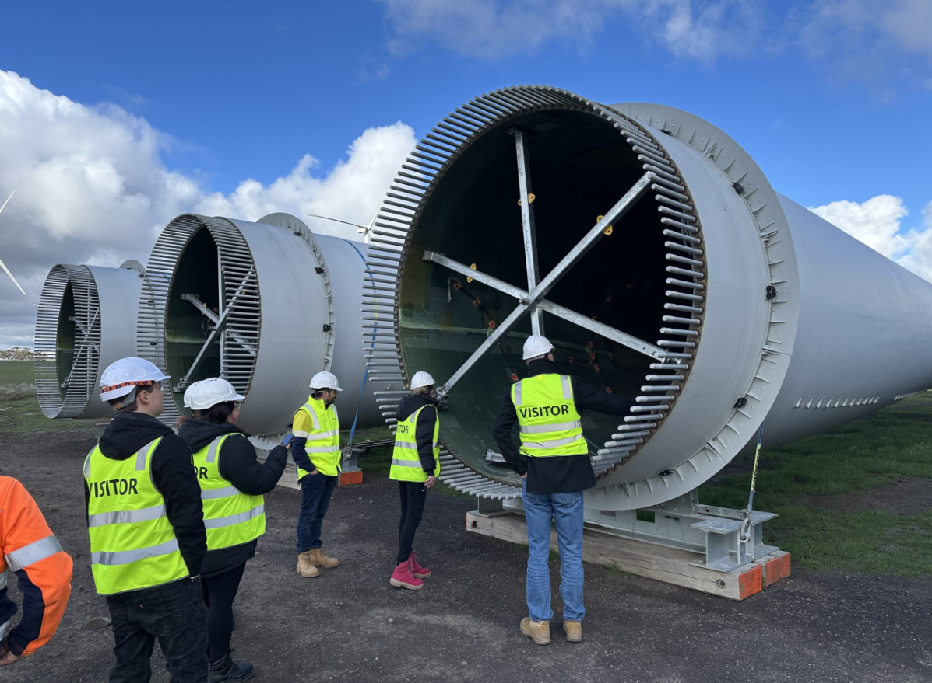
AEIC team members visiting a wind farm construction

Administrative support
While the Commissioner is an independent appointment, there are some things that require access to specific systems and processes. We receive administrative support on these responsibilities through the department.
For example, the Commissioner is required to attend Senate Estimates when called at to respond to parliamentary requests for information.
The AEIC Office staff are employed by DCCEEW for administrative purposes. All HR and payroll systems are through the department.
The AEIC is provided a budget by the department and is responsible to managing to this budget. This includes salaries and other staff costs, contract costs, travel expenses and other administrative costs.
We are also supported through the department for legal services where required. This includes freedom of information requests and requests from the Commonwealth Ombudsman.
In 2025 we were also supported by the DCCEEW strategic communications area in updating our branding and templates, using in-house resources.
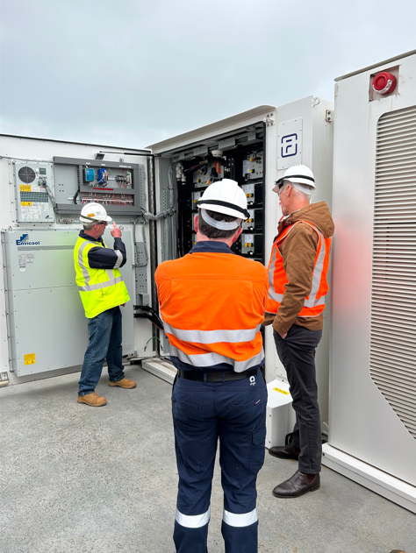
Visiting a grid-scale battery facility

Appendix C: Complaint issues and definitions
Complaint issue | Definition
Amenity | Refers to the pleasantness, attractiveness, and overall enjoyment of a living environment. Complaints related to amenity concern elements that negatively impact the comfort and well-being of residents; such as visual impacts, loss of tranquillity, and changes to the character of the area.
Commercial agreement | Issues related to agreements between landowners and developers (or other relevant parties), including concerns about the fairness of terms, compensation for impacts, confidentiality clauses, and adherence to contractual obligations.
Community engagement | Deficiencies or perceived shortcomings in the processes used by project developers to inform, consult, and involve the local community in decision-making. Includes concerns about the adequacy of consultation events, the accessibility of information, transparency, and responsiveness to community concerns.
Construction | Problems or disruptions caused by the construction phase of a project. Examples include traffic disruptions, noise pollution, dust and air-quality concerns, damage to infrastructure, biosecurity breaches, safety hazards and issues with access to a site.
Decommissioning | Concerns regarding the plans, costs, and long-term environmental and social impact of decommissioning the project at the end of its operational life. Includes questions about financial assurance, removal of infrastructure, and land restoration.
Economic loss | Negative impacts on the financial well-being of landowners, businesses, or the community. Concerns may include property devaluation, lost income from tourism or agriculture, increased insurance costs, and effects on local employment.
Health | Alleged adverse effects on physical or mental health attributed to the project's construction or operation. Common concerns include sleep disturbance, stress, anxiety, headaches, nausea and the potential for infrasound or other physiological effects.
Land access | Disputes or challenges related to access to land for construction, maintenance, or operation of a project, often involving easements, rights-of-way, biosecurity and impacts on existing land use.
Maintenance/operations | Problems arising from the routine operation and upkeep of a project after construction. Examples include noise from faulty equipment, vibration, visual impact of malfunctioning lights, inadequate response to maintenance requests, and improper storage of waste.
Natural environment | Concerns about the project's impacts on local flora and fauna, ecosystems, waterways, soil, air quality and biodiversity.
Noise | Disturbance caused by sound generated from the project's operation. In wind farms, this often refers to turbine noise, including tonal sounds or infrasound. In solar farms and BESS facilities, noise from inverters, transformers, or cooling systems can be a concern.
Planning process | Objections to the planning application process, the assessment methodology, or the way that regulators or decision-makers consider community input. This can include issues regarding the scope of EIS studies or breaches of conditions and code of conduct.
Route selection | Primarily applicable to transmission line projects. Concerns related to the selection of the chosen path for the line, including alternative route options, proximity to residences, and the impact on land use and environmental features.
Safety | Risks to public or worker safety arising from the project's construction or operation. This can encompass issues related to fire hazards, electrocution risks, traffic accidents, aircraft navigation, and the structural integrity of infrastructure.
Shadow flicker | Annoyance or disturbance caused by the intermittent flickering effect created when sunlight is interrupted by the rotating blades of a wind turbine.
Systemic issue | Concerns about fundamental problems with industry-wide practices, regulations, or government policies related to renewable energy development (e.g. decommissioning bond adequacy).
Technology selection | Disagreements or concerns regarding the specific technologies used in a project, such as the type of wind turbines, the chemical composition of battery storage systems, or the suitability of a particular technology for the local environment.
Vibration | Discomfort or structural damage caused by vibrations generated from the project's operation (most commonly associated with wind turbines).
Wind farm maintenance/operations | Problems arising from the routine maintenance, or any problems arising on wind farms and facilities.

Appendix D: Excerpts from Community Engagement Review (2023)
Full documents can be found at Community Engagement Review – DCCEEW
Theme 1: Developer performance and selection
Improve community engagement by motivating developers to achieve best practice and only selecting reputable developers for new project developments.
Recommendation 1. The Minister to initiate a process to appoint an independent body to design, develop, implement and operate a developer rating scheme.
Recommendation 2. The Commonwealth, state and territory governments to continue their deployment of programs to better plan and control development of new generation and transmission projects.

Theme 2: Selecting the best sites
Reduce and eliminate unnecessary community engagement by selecting the best project sites and avoiding poor and inappropriate sites.
Recommendation 3. State and territory governments to support and expedite sourcing information that is necessary for contemporary land use planning.
Theme 3: Reform environmental and planning approvals
Reduce and minimise the need for elongated community engagement by re-engineering planning and environmental assessment and approval processes.
Recommendation 4. To progress, complete and expedite the deployment of process reforms currently being contemplated by the jurisdictions, which will materially improve processes and help reduce the time needed to obtain planning and environmental approvals for projects.
Theme 4: Complaint management
Reduce unresolved and lengthy complaints by ensuring best practice complaint handling, backed up with a new, relevant ombudsman scheme in each state.
Recommendation 5. State and, where applicable, territory governments to establish and implement a new ombudsman function focussed on handling complaints about renewable energy generation, large-scale storage and new transmission infrastructure.

Theme 5: Messaging and governance
Improve community understanding of the need for the transition, including what is to be deployed in their region as well as where, when and why. Ensure appropriate governance is in place to manage the broader impacts of the transition as well as oversight of projects of national significance.
Recommendation 6. The Minister to initiate a process for the development and execution of a communications program that provides local communities with a clear narrative about the pragmatic reasons for the energy transition.
Recommendation 7. The Commonwealth to work with state and territory governments to implement appropriate oversight governance arrangements that should be in place for transition projects of national significance and to provide a cross-discipline, whole-of-government approach to the energy transition.
Theme 6: Coordinated economic development and community benefits
Improve acceptance of the transition changes and impacts by engaging the community to identify opportunities and enable sustainable benefit sharing. These opportunities include local economic development in conjunction with numerous other opportunities that will benefit the broader community.
Recommendation 8. The Commonwealth to work with jurisdictions to ensure appropriate arrangements exist at state/territory and national levels to provide a cross-discipline, whole-of-government approach to identify, cultivate and generate tangible economic and investment attraction opportunities for regional businesses, including First Nations people and their enterprises.
Recommendation 9. Stateterritories and local governments to encourage local community groups to proactively identify opportunities for the broader community’s benefit, as well as to take ownership of sound opportunities to secure support and funding.

Links to PDF and MS Word versions of the full report are available via the AEIC website at:
Community Engagement Review Report

Contact details
The Office of the Australian Energy Infrastructure Commissioner can be contacted via:

Telephone (toll-free): 1800 656 395
Email: aeic@aeic.gov.au
Post: Australian Energy Infrastructure Commissioner
PO Box 24434
MELBOURNE VIC 3001

www.aeic.gov.au
1800 656 395
aeic@aeic.gov.au

