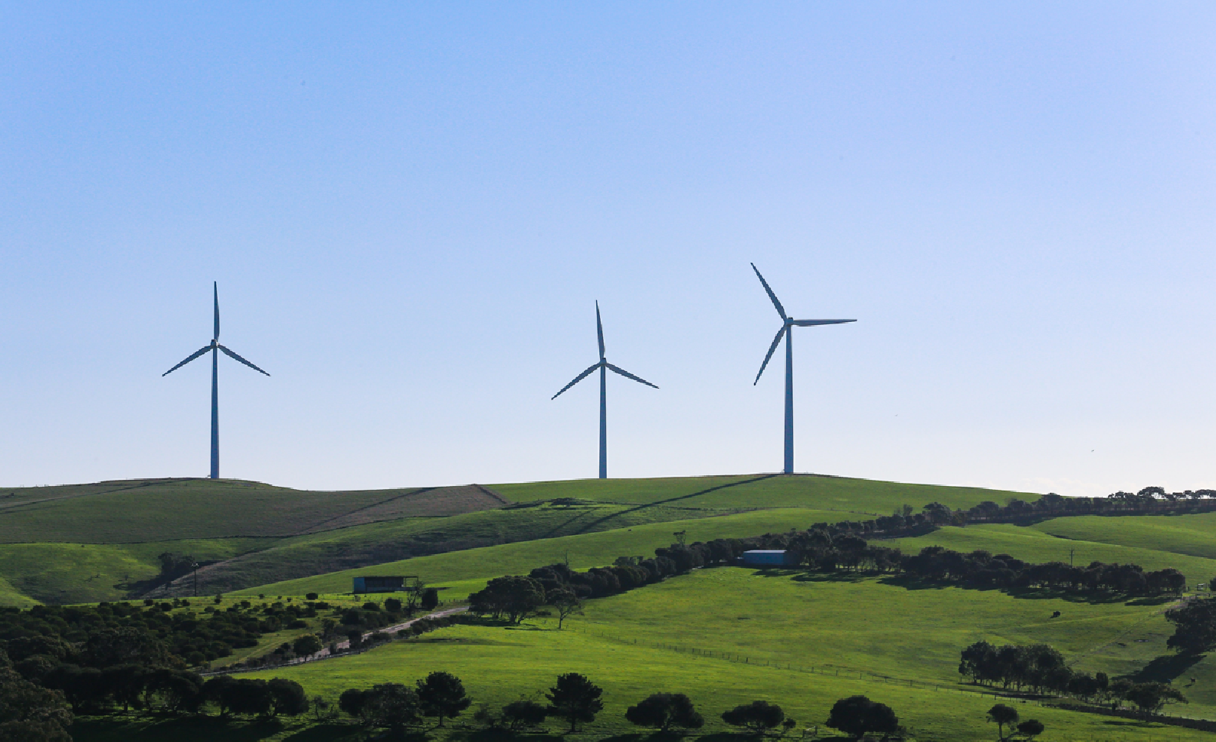



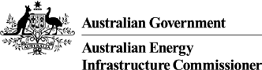

Australia’s energy shift – explainer
The Australian Energy Infrastructure Commissioner (AEIC) and the Net Zero Economy Authority (NZEA) have complementary roles in shaping and supporting our nation’s energy transition – and we share the key goal of enabling local communities, industry and governments to navigate this dynamic energy shift.
Our objective in publishing this short explainer is to provide the clearest possible summary of our answers to some questions that we are occasionally asked in different public forums.

Why is the energy shift happening?
Australia’s energy system has gone from mostly relying on a small number of coal-fired power stations in a few local areas, to increasingly harnessing a larger number of more spread-out and renewable energy sources.
These long-term changes have multiple causes and moving parts. As electricity demand grows and coal-fired generators get older and more expensive to maintain, all Australians need our energy system to be robust and keep up with our basic needs. Two coal-fired power stations have closed in past five-
years and five are expected to close in the next five years. These are technological and economic issues that governments would have to tackle even if they were not also responding to the challenges of global climate change.
On the best available evidence and independent analysis, renewable energy alongside new supporting electricity infrastructure is cheaper and more reliable than other alternatives. This is why renewable sources have already grown from providing around 27% to the national electricity market in 2020, to 43% in 2025.

AEIC.gov.au | netzero.gov.au

What does it mean in practical terms?
With the need to replace ageing power plants, Australia’s energy shift is already happening.
How it happens, and what is achieved at a project, regional and national level in coming years, depends on all of us. The closure of old stations and the building of new infrastructure bring real change to communities. Governments at all levels are working with communities and industry to better plan for the challenges and opportunities that come with these changes and new investments.
For example, at the federal level the Australian Government is pursuing its policy objectives for a fair, orderly and efficient transition through the Net Zero Plan.

How is it being managed – and by who?
Nation-wide, the Energy and Climate Change Ministerial Council (ECMC) is the peak forum for the Commonwealth, State and Territory governments to collaborate on these issues.
New renewable energy projects and the infrastructure that supports them – such as transmission lines, substations and energy storage – must go through established planning and approval processes. These processes operate at both state and national levels, depending on the type, scale and location of a project. They are designed to assess environmental, technical and social impacts as well as to identify community benefits. They include formal opportunities for community consultation, so local residents, landholders and other stakeholders can provide input and raise questions before decisions are made.
The AEIC helps local communities to get meaningful answers to their questions or concerns about new or existing wind and solar farms, grid-scale energy storage (like pumped hydro or large batteries), and new major powerline projects. We promote credible sources of trusted information, share insights on best practice approaches, and engage across governments and stakeholders on the outcomes from the Community Engagement Review (2023).
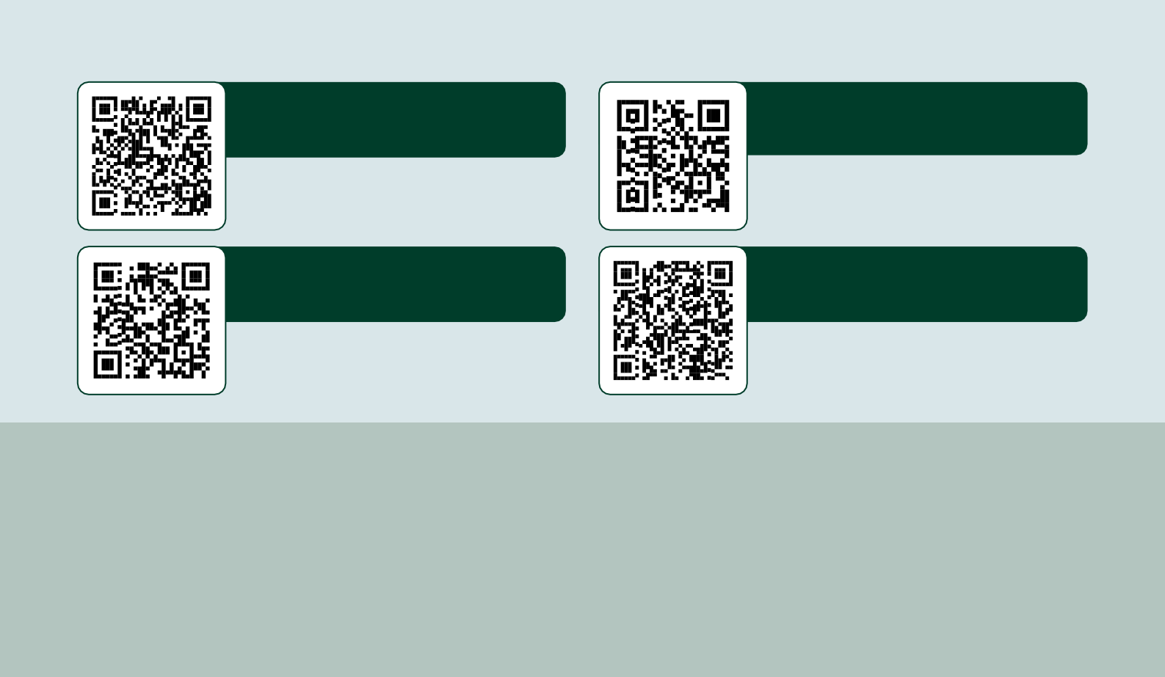
The NZEA exists to support workers and communities most affected by the energy transition. This includes helping workers in coal and gas power facilities move into new industries, access training, and reskilling opportunities, and receive career and financial guidance so they can make informed decisions about their future. The NZEA helps shape stronger futures so our industrial regions, local communities and workers can thrive in a net zero economy.
For more information:
... on where in Australia projects are being developed
... on what resources exist to drive best practice
Energy infrastructure
- AEIC website
Best practice and Resources
- AEIC website
... on how the NZEA works in the regions
... on why support for workers is essential
Regions
- NZEA website
Energy Industry Jobs Plan
- NZEA website
Acknowledgement of Country
We acknowledge the Traditional Custodians of Australia and their continuing connection to land and sea, waters, environment and community.
We pay our respects to the Traditional Custodians of the lands we live and work on, their culture, and their Elders past and present.
AEIC and NZEA Australia’s energy shift – explainer (v1.0) – May 2026
© Commonwealth of Australia

