Fact sheet: Wind Energy Facility Shadow flicker
Published May 2026, version 1
This fact sheet provides an overview of shadow flicker and how it is assessed and regulated in Australia, at the time of publication.

What is shadow flicker?
Shadow flicker occurs when the sun is located behind a wind turbine and the rotation of the wind turbine blades cast intermittent shadows, creating a flicker or strobing effect.
There are a number of things that impact how a residence might be affected by shadow flicker - the wind turbine height and size of rotor blades, the position of the sun, the time of year, surface topography and surrounding vegetation.
While shadow flicker can technically occur over several kilometres, its intensity will diminish over distance. It is typically considered noticeable at distances of less than 1.4 km, although individuals can have varying sensitivity levels.¹
Since shadow flicker is experienced when the sun is in specific locations in relation to a turbine and the path of the sun changes throughout the year, impacts of shadow flicker at a location do not happen continuously. Shadow flicker is typically experienced over short durations in the morning or evening when the sun is close to the horizon, and may only be experienced for periods of weeks at certain times of year.

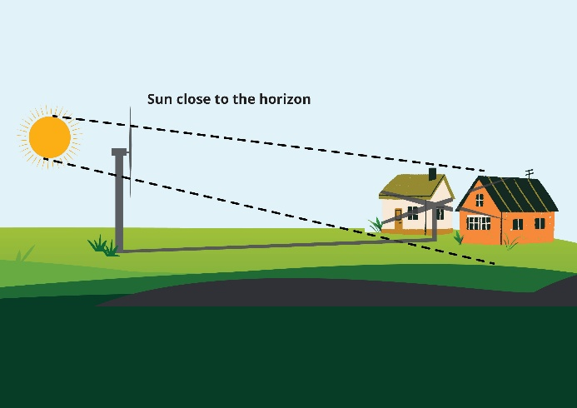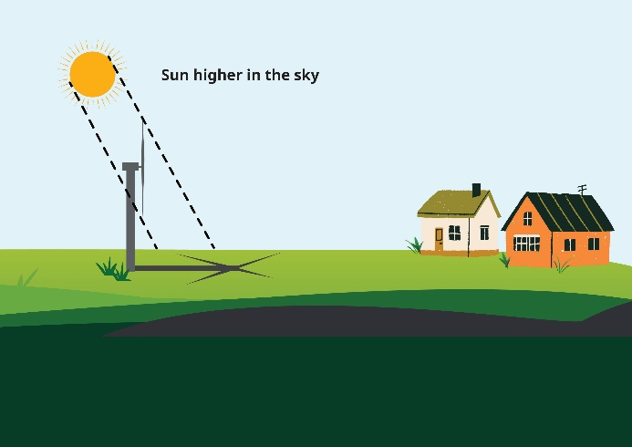

Community concerns associated with shadow flicker
Some people near proposed and operating wind farms can be worried about potential impacts from shadow flicker.
There have been concerns raised in literature about potential for shadow flicker to cause health impacts for those with photosensitive epilepsy. The risk of shadow flicker inducing epileptic seizures has been examined and found to be extremely low, with impacts likely at frequencies well above those from wind turbines – impacts happen above 2.5Hz, and a wind turbine shadow flicker is generally at 1Hz or less.²
Another concern relating to shadow flicker is that motorists will be distracted when driving on the road. This risk is also considered negligible, as the effects of shadow flicker are similar to that of a moving vehicle passing trees or stationary vehicles with the sun behind them.
While the direct health impacts are also considered to be negligible, residents nearby to wind farms can experience annoyance from shadow flicker.³ The degree of annoyance will likely be influenced by a range of subjective and psychological factors, as well as the location, design and operation of the wind farm.
This is why shadow flicker needs to be assessed as part of any new proposal.

Current regulatory frameworks
Existing amenity-based setback requirements for noise and visual impact will help to minimise the impacts of shadow flicker on local residents. There are also specific shadow flicker criteria.
Australia’s draft National Wind Farm Development Guidelines (2010) proposed a best practice methodology for assessment and mitigation of shadow flicker. These draft guidelines were not finalised or adopted as national standards but are often still referenced.
Currently, shadow flicker standards are set by each state, in some cases relying on the draft national guidelines. This is shown in the table on the following page.

Shadow flicker assessment for new proposals
Shadow flicker impacts are assessed as part of approval processes, using computer modelling to predict the amount of impact received at a resident’s external window or garden area. These are then assessed against regulatory standards. Modelling is often based on ‘worst-case’ scenarios which assume no cloud cover or screening, full sun exposure, and continuous operation of the turbine. This means the modelling often over-estimates shadow flicker impacts.
The Shadow Flicker Assessment will assess potential impacts on nearby residents based on modelling outlined in the assessment methodology. Residents’ locations are mapped, and the number of hours of likely impact for the year for each given location are then determined. These assessments can also indicate what times of year impact is most likely, and help to consider what could be done to reduce impacts.
Once a wind farm development is approved or constructed, any new buildings proposed near the wind farm should check whether shadow flicker impacts are likely and consider how to design them to avoid or minimise impacts.

Summary of shadow flicker standards by state and territory
State | Standard | Reference | State Dept.
Queensland | 30 hrs/yr for sites with existing or approved sensitive land use, and a maximum of 30 minutes/day | Planning Guideline State code 23: Wind farm development | Department of State Development, Infrastructure and Planning
New South Wales | Projects should be designed to avoid visually dominant turbines and shadow flicker of >30 hrs/yr (unless private agreement addresses impact) | Renewable Energy Planning Framework  Wind Energy Guideline | Department of Planning, Housing and Infrastructure
Victoria | Max. of 30 hrs/yr for non-associated dwellings near a project | Planning Guidelines for Development of Wind Energy Facilities | Department of Transport and Planning
Western Australia | In development  propose a max. of 30 hrs/yr and 30 minutes/day at visually sensitive land use on non-host lots (or 10 hrs/yr when considering predicted actual shadow flicker modelling) | Draft Renewable Energy Planning Code and Guidelines | Department of Planning, Lands and Heritage
South Australia | Shadow flicker impacts on nearby property owners/occupiers should be avoided or minimised  Draft National Guidelines often used as technical reference | Wind farm planning policy | Department of Housing and Urban Development
Tasmania | Draft National Guidelines often used as technical reference | - | Department of State Growth
Northern Territory | Currently no specific shadow flicker provisions outlined in the Northern Territory Planning Scheme | - | Department of Lands, Planning and Environment
ACT | Currently no specific shadow flicker provisions set out in ACT planning guidelines | - | Environment, Planning and Sustainable Development Directorate

Management of shadow flicker in operation
Once a wind farm is built, it can be difficult to confirm whether the modelling predictions were accurate. This is because they are modelled over a year long period, and actual impacts are intermittent and short duration.
The best indicator of compliance is the actual experience of neighbours. In AEIC’s case handling role, complaints about shadow flicker impacts from operating wind farms are very rare.
There are things that can be done if shadow flicker becomes a concern, such as screening with plants or blinds. In exceptional circumstances, curtailing turbines for short periods of intense flicker may be considered.
The first step is to raise the concerns with the operator and ask for them to take action.

More information
For more information on our role – including how to seek assistance from the AEIC through our complaints and enquiries processes – please contact us. Web www.aeic.gov.au Email aeic@aeic.gov.au Phone 1800 656 395

References
- National Health and Medical Research Council (NHMRC) (2015), Informational paper: Evidence on wind farms and human health, February.
- Australian Government (2010), National Wind Farm Development Guidelines DRAFT, produced by Environment Protection and Heritage Council (EPHC), July, p. 149.
- Freiberg, A, Schefter, C, Hegewald, J and Seidler, A (2019), ‘The influence of wind turbine visibility on the health of local residents: A systematic review’, International Archives of Occupational and Environmental Health, 92(5): 609-628. https://doi.org/10.1007/s00420-019-01403-w

Acknowledgement of Country
We acknowledge the Traditional Custodians of Australia and their continuing connection to land and sea, waters, environment and community. We pay our respects to the Traditional Custodians of the lands we live and work on, their culture, and their Elders past and present.
© Commonwealth of Australia 2026.
Unless otherwise noted, copyright (and any other intellectual property rights) in this publication is owned by the Commonwealth of Australia (referred to as the Commonwealth). All material in this publication is licensed under a Creative Commons Attribution 4.0 International Licence except content supplied by third parties, logos and the Commonwealth Coat of Arms.
The Australian Government acting through the Department of Climate Change, Energy, the Environment and Water has exercised due care and skill in preparing and compiling the information and data in this publication. Notwithstanding, the Department of Climate Change, Energy, the Environment and Water, its employees and advisers disclaim all liability, including liability for negligence and for any loss, damage, injury, expense or cost incurred by any person as a result of accessing, using or relying on any of the information or data in this publication to the maximum extent permitted by law.

