Fact sheet: Wind farm noise limits and criteria

Published June 2026, version 1
This fact sheet provides an overview of noise limits and regulations for wind farm facilities in Australia.

Wind farm noise
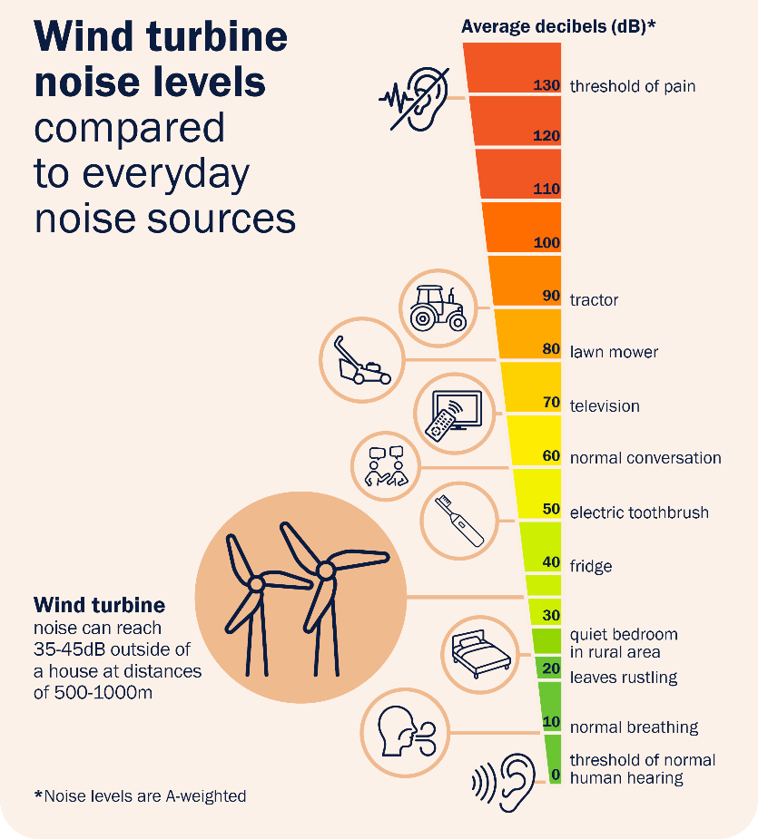
Wind turbines will generate some level of noise during operation. This can be from the mechanical components of the turbine, or the blade rotating through the air creating airflow disturbance. These noise levels will vary with wind speed, atmospheric conditions, and local topography, amongst other things.
Noise limits have been set to minimise the level of noise experienced by local residents. This helps to balance the need for maintaining acoustic amenity while allowing projects to proceed. Setback distances have also been implemented by most states which can help to manage noise concerns.
Human hearing usually ranges from 0 dB(A) to 130 dB(A), with the latter being the threshold of pain. A wind turbine operating at moderate wind speed at distances of 500 to 1,000 metres can reach between 35 and 45 dB outside of the house.¹ For comparison, a quiet bedroom in a rural area ranges from 20 to 25 dB, whispering around 30 dB, and a normal conversation around 60 dB.
Noise levels will be quieter inside a house compared to outside, and will vary depending on the distance from the turbine. Even when complying with noise requirements, a wind farm will be able to be heard by people at times.

1 of 5

Current noise regulations and compliance frameworks
Noise standards in Australia are incorporated into state (and local) planning frameworks and vary by jurisdiction. Current noise limits are based largely on avoiding or limiting sleep disturbance² and are consistent with guidance issued by the World Health Organization.³ The limits, and their respective regulatory frameworks, are summarised below.
Noise levels are regulated at the state level by respective regulatory authorities. This is usually the role of the environmental protection authority (such as an EPA). In Queensland, turbine noise is regulated through the Department of State Development, Infrastructure and Planning’s State Assessment and Referral Agency (SARA).
The exact regulatory role of the authority can vary, particularly between approval, construction and operational phases.
In Victoria, EPA Victoria is responsible for the regulation of wind turbine noise once a turbine becomes operational. The relevant planning authority will regulate noise limits during the construction and commissioning stages. Tasmania’s recently revised noise limits also apply for operational wind turbines but not to construction noise.
In contrast, South Australian wind farm developments are initially referred to EPA SA by the SA Planning Authority. EPA SA advises on compliance and sets conditions if the development is approved. Once constructed, EPA SA’s regulatory role focuses on assessing post construction noise reports.
Different states and territories also use different standards to assess compliance. For example, Victoria uses the New Zealand NZS 6808 standards (1998 or 2010). The South Australian EPA has set its’ own guidelines for assessing and managing wind farm environmental noise. These have also been adopted, with some amendments, in Tasmania and in NSW. In Queensland, limits are set through State Code 23. These standards are outcome based and must be met regardless of turbine size or design.
State | Noise limit | Regulatory Framework | Compliance Regulator**
Queensland | Hosts: 45 dB(A) or background noise +5 dB(A)* (8pm—6am)  Non-hosts: 35 dB(A) or background noise +5 dB(A)* (8pm—6am); 37 dB(A) or background noise +5 dB(A)* (6am— 8pm) | State Code 23: Wind farm development and State Code 23 Planning Guideline | Department of State Development, Infrastructure and Planning, SARA
New South Wales | 35 dB(A) or background noise +5 dB(A)* | NSW Renewable Energy Planning Framework and Wind Energy Guideline (Noise Technical Supplement) | NSW EPA
Victoria | 40 dB(A) or background +5 dB(A)*  45 dB(A) or background +5 dB(A)* for premises subject to stakeholder agreement  35 dB(A) for ‘high amenity’ areas | Environment Protection Act 2017 and Environment Protection Regulations 2021 | EPA Victoria
Western Australia | 35 dB(A) | Environmental Protection (Noise) Regulations 1997 | Department of Water and Environmental Regulation
South Australia | 35 dB(A) or background noise +5 dB(A)* (rural living zones)  40 dB(A) or background noise +5 dB(A)* (other zones) | Wind farms environmental noise guidelines | EPA SA
Tasmania | 35 dB(A) or background noise +5 dB(A) | Noise limits for wind energy projects | EPA Tasmania
*whichever is greater.**with respect to operational wind farms. Note: there are currently no operational wind farm projects in the Northern Territory or the ACT and no specific limits or framework.
In most states and territories, the noise standard is the greater of a set noise limit, or combination of the background noise plus 5dB(A). Because wind energy projects are often located in rural areas where ambient background noise levels (typical noise levels prior to the wind farm being developed) are low, the set noise limit the set noise limit will generally apply at lower wind speeds. At higher wind speeds, the background-adjusted noise limit may become greater than the set limit due to the background noise arising from wind-induced noise through vegetation.

Noise level assessment
In the planning process, proponents must submit environmental assessments to the relevant planning authority. For wind energy projects this will include a noise assessment, called a pre-construction or predictive assessment. This will generally involve measuring existing background noise levels, and computer modelling to predict the changed noise level after installation of the turbine.
The type of turbine, turbine height and location will all affect noise levels. There are also adjustments made for noise characteristics like tone, sometimes heard as a humming or droning sound. The adjustments and characteristics assessed will depend on the jurisdiction.
The result of the noise modelling is then compared to the required limits. Where the predicted noise is above the limit the proponent will need to either reduce the noise levels, or in some cases come to an agreement with any impacted property owners.
Noise levels are typically assessed at “noise sensitive locations.” These are generally houses or places where people spend a lot of time like a school or a childcare centre. Noise levels are assessed outside and away from any local noise sources like air conditioners or generators.

Operating noise compliance
Once a wind farm starts operating, the wind farm operator must show that they are in compliance with the noise requirements. In general, they will undertake a post-construction noise assessment. This will involve measuring the noise when the turbines are operating and comparing it to previous levels and the required limits.
Measurements of noise levels are conducted using a noise monitor typically located outside of a dwelling or sensitive receptor. This is not always possible, and some jurisdictions permit alternative approaches. As with the pre-construction assessment, adjustments are made for certain noise characteristics, or to exclude noise data that is impacted by other sources such as crickets, wind-causing noise on the microphone or human impacts. In some cases, the regulator may require this to be reviewed or independently verified.
There can be a significant time period between when the first turbine(s) becomes operational and when full post-construction noise assessments can be conducted as it can take time for all turbines to be fully commissioned and to collect and analyse all the data. To check that noise levels are at expected levels, it is considered good practice to conduct sound measurements once the initial turbines begin operating.
In Victoria the operator is required to have a noise management plan which will identify risks, mitigation strategies, and complaints management procedures. This is not mandated in other jurisdictions, although Western Australia and Queensland have similar requirements which are applied on a project-to-project basis. AEIC considers this to be best practice.
Wind turbine noise limits apply for the duration of a project’s life. Periodic assessments to show ongoing compliance may be needed, or can be required where the regulator has information that indicates that noise levels may have increased.

Community concerns associated with noise from wind farm facilities
Noise assessments for wind farm facilities are technically complex and along with visual impacts, are normally a primary concern for community. The process for assessing and monitoring the acoustic impact can affect communities’ confidence and trust in the approvals process and the post-construction assessments.
Community concerns about the impacts of wind turbine noise on humans include impacts from audible noise, infrasound, and low-frequency sound. Scientific findings from reputable peer-reviewed research suggests there is no consistent evidence that wind turbine noise directly cause adverse health impacts.⁴ Infrasound and low-frequency noise caused by wind turbines, for example, is comparable to other natural and human-made noise sources.^{5,6}
Whilst some sources and papers state that there are proven impacts from wind turbine noise, the AEIC is not aware of any reputable, peer-reviewed studies that have found significant health impacts from wind turbine noise. We do, however, acknowledge that some community members tell us that they are experiencing significant impacts despite what this research has found. Industry and governments should continue to monitor and undertake relevant research to ensure the research keeps up with developments in technology.
Based on the available evidence, it is also unlikely that wind farm noise is directly causing sleep disturbance. An association has been reported between wind turbine noise and annoyance.⁷ This can lead to increased anxiety and stress levels and can mean that people are more attuned to any noise.⁸ The level of annoyance will also be influenced by noise sensitivity and subjective attitudes towards wind turbines.⁹
Residents concerned about noise inside the dwelling could have their house assessed by a qualified acoustician. This may help to determine the root cause of the noise. Residents having difficulty sleeping should seek advice from their doctor.
Concerns or complaints about wind turbine noise should be raised with the operator in the first instance. This is especially important if the type of noise has changed and/or increased. Sometimes wind turbine components can make louder or different sounds when they need maintenance or replacement, and the operator is best placed to investigate this and action it quickly.
Complaints can be made to respective state EPAs or relevant authorities. The AEIC office can also assist community members with complaints and enquiries relating to wind farms and other large-scale renewable energy and transmission infrastructure. We do not regulate noise limits but can help with relevant company contacts, navigating complaint processes and providing information.

More information
Learn more about the Australian Energy Infrastructure Commissioner.
Web: www.aeic.gov.au
Email: aeic@aeic.gov.au

References
- Victorian Department of Health (2013), Wind farms, sound and health: Community information, April.
- Davy, LJ, Burgemeister, K and Hillman, D (2018), ‘Wind turbine sound limits: Current status and recommendations based on mitigating noise annoyance’, Applied Acoustics, 140: 288-295. https://doi.org/10.1016/j.apacoust.2018.06.009
- World Health Organization (WHO) (2018), Environmental Noise Guidelines for the European Region, January.
- National Health and Medical Research Council (NHMRC) (2015), NHMRC statement: Evidence on wind farms and human health, February.
- Marshall, NS, Cho, G, Toelle, BG, Tonin, R, Bartlett, DJ, D’Rozario, AL, Evans, CA, Cowie, CT, Janev, O, Whitfeld, CR, Glozier, N, Walker, BE, Killick, R, Welgampola, MS, Phillips, CL, Marks, GB and Grunstein, RR (2023), ‘The health effects of 72 hours of simulated wind turbine infrasound: A double-blind randomized crossover study in noise-sensitive, healthy adults’, Environmental Health Perspectives, 131(3): 37012-12. https://doi.org/10.1289/EHP10757
- Zajamsek, B, Hansen, KL, Nguyen, PD, Lechat, B, Micic, G and Catcheside, P (2023), ‘Effect of infrasound on the detectability of amplitude-modulated tonal noise’, Applied Acoustics, 207: 109361. https://doi.org/10.1016/j.apacoust.2023.109361
- Commonwealth of Australia (2022), 2021 annual and final report of the Independent Scientific Committee on Wind Turbines.
- NHMRC (2015), NHMRC statement: Evidence on wind farms and human health.
- Knopper, LD and Ollson, CA (2011), ‘Health effects and wind turbines: A review of the literature’, Environmental Health, 10(1): 78. https://doi.org/10.1186/1476-069X-10-78

Acknowledgement of Country
We acknowledge the Traditional Custodians of Australia and their continuing connection to land and sea, waters, environment and community. We pay our respects to the Traditional Custodians of the lands we live and work on, their culture, and their Elders past and present.

© Commonwealth of Australia 2026
Unless otherwise noted, copyright (and any other intellectual property rights) in this publication is owned by the Commonwealth of Australia (referred to as the Commonwealth).
All material in this publication is licensed under a Creative Commons Attribution 4.0 International Licence except content supplied by third parties, logos and the Commonwealth Coat of Arms.
The Australian Government acting through the Department of Climate Change, Energy, the Environment and Water has exercised due care and skill in preparing and compiling the information and data in this publication. Notwithstanding, the Department of Climate Change, Energy, the Environment and Water, its employees and advisers disclaim all liability, including liability for negligence and for any loss, damage, injury, expense or cost incurred by any person as a result of accessing, using or relying on any of the information or data in this publication to the maximum extent permitted by law.

