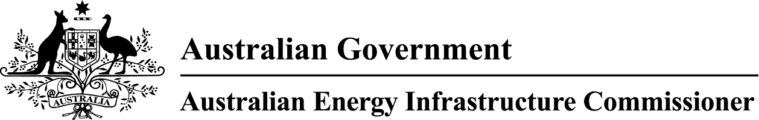

Tony Mahar Website address – Transcript

Hi, I'm Tony Mahar, the Australian Energy Infrastructure Commissioner.
I've spent much of my career working with people in regional Australia. I've listened to different views, tackled complex issues and helped find practical and fair solutions.
That experience shapes how I approach this role. My focus is on helping make Australia's energy transition smoother and fairer for everyone involved.
The AEIC is an independent role that reports to the Minister for Climate Change and Energy.
With my office team, I work with communities, industry, local, state and federal governments. One of our key roles is to bring these groups together. We share information, highlight issues and help build a better understanding of the challenges and opportunities involved in the energy transition.
We help people with their inquiries and complaints about major energy projects. This includes wind farms, large-scale solar, energy storage and transmission projects.
Our job is to listen, gather information and work with stakeholders to help address concerns. We also encourage better communication and stronger engagement between projects and communities.
We don't approve or stop projects. However, we can help people understand the process, navigate complex issues and connect with the right information.
We also work to make information easier to understand and share lessons that can improve future projects.
For me, it comes down to three things: fairness, clarity and respect.
When people have better information and feel heard, better outcomes are possible.
To learn more or get in touch, visit aeic.gov.au, email aeic@aeic.gov.au or call 1800 656 395.

